German Chancellor visits HARTING at HANNOVER MESSE
Technology Group presenting innovations for a climate-neutral future

Espelkamp/Hanover, 23 April 2024 --- German Chancellor Olaf Scholz, Jonas Gahr Støre, Prime Minister of Norway and Robert Habeck, Federal Minister of Economics and Climate Protection: at HANNOVER MESSE 2024 they learned about the highlights of the HARTING Technology Group - connectivity solutions for the focus topics of carbon-neutral production, energy for industry and AI. The world’s most important industrial trade fair is devoted this year to the goal of a powerful and sustainable industry. In this context, the HARTING Technology Group is presenting its products for the All Electric Society. A green future in which all energy is derived from renewable resources and subsequently converted into electricity.
In launching the show, Olaf Scholz and Jonas Gahr Støre stopped off at the HARTING fair stand and watched attentively as a fuel cell in which hydrogen is converted into energy was explained to them. This is a joint project with the Norwegian company TECO2030, whereby HARTING is supplying the connection technology. Specifically, the Technology Group is contributing a Han-Modular® and a connector combination of M12/RJ45 for the fuel cell module. In addition, for the entire infrastructure: hydrogen production, transport and energy transmission. “We want to shape the future with technologies for people – that is our vision. And one thing is very clear: we can only create a climate-neutral future with state-of-the-art technology. The connectors and cable solutions required to achieve this – are supplied by us”, as Philip Harting, CEO of the HARTING Technology Group underlined.

Habeck, HARTING and the challenges ahead

On the second day of the trade fair, HARTING presented a project for the AI-supported development of connectors to the Federal Minister for Economic Affairs and Climate Protection, Robert Habeck. Together with partners Microsoft and Siemens, the technology group presented to him how artificial intelligence can revolutionise application-oriented developments in industrial products: Input in natural language is interpreted by highly developed Microsoft recognition algorithms and contextual understanding in order to adapt products to specific requirements and create 3D models for CAD software (Siemens’ NX™ software) using a HARTING connector AI. This accelerates development processes, enables connectivity solutions that are ideally customised to the application and ensures the lowest possible use of resources.
At the Hannover Messe, the technology group also provided information on the course of business to date. This year, HARTING is expecting sales revenues to decline by -8 percent by comparison with the previous year’s results (1,036 million). "We predicted this six months ago and see our planning confirmed," says Philip Harting. The reasons for this are the limping German economy, high energy prices, the challenges posed by war and terror and the lack of access to resources and raw materials. "However, the worst is over. Incoming orders are picking up again." Harting sees growth opportunities in the medium term through the possibilities arising from decarbonisation, electrification and digitalisation as part of the industrial transformation. The Technology Group's mission statement - "Connecting the All Electric Society" - is based on this. The transfer of the "Data" and "Power" lifelines.

HARTING’s vision of the future: Connecting the All Electric Society

The All Electric Society describes the vision of a world in which energy requirements are met by electricity. The energy required is gained from renewable resources such as wind and solar, subsequently converted into electricity and distributed across intelligent networks in line with demand. Sector coupling is one key prerequisite for the successful implementation of the AES. Sectors here refer to the areas of mobility, industry, energy, infrastructure and agriculture. The aim is to interconnect these sectors to form an overall system. How? By way of the lifelines of data and power. These form the backbone of sector coupling and must be able to flow unhindered throughout the system. And that’s where HARTING enters the picture! With innovative connection technology and individual, customized cable solutions.

These are HARTING’s key topics at the trade fair:

Attuned to the trade fair motto of “Energizing a Sustainable Industry”, the Technology Group is presenting innovative technologies on its stand – this year focussing on the sectors of energy, industry, mobility and agriculture.

The energy sector: The focus is on connection technology, particularly for the storage of energy in battery systems or in hydrogen storage systems and the intelligent control of energy flows via smart grids. The following products are deployed here, among others: besides the Han-Modular® and the M12 and RJ45 network connectors, also the Han-Eco® – which won the “Data Centre Excellence Award” in the “Power distribution solution of the year for data centres” category. The prize was bestowed by the British trade journal Electrical Review.

The industry sector: In this sector, the Technology Group is presenting connectivity solutions for intelligent control systems in production. Modern factory management requires access to all available data at all times. The carbon footprint or energy balance can be evaluated in this way, for example. At the trade fair, HARTING is showcasing an online configurator which can be used to configure individual M12 cabling.

The mobility sector: Here, the Technology Group is focussing on charging solutions for electric cars at this year’s fair in Hanover. The NACS connector (North American Charging Standard), for example, is suitable for applications in private homes and vehicles.

The agriculture sector: With regard to the agriculture sector, HARTING will be featuring products for electrical power transmission on its trade fair stand. Meanwhile, today’s tractors are ultra-modern vehicles. They are connected to the internet via GSM systems and more and more systems are communicating with each other to further increase performance in the field. However, when it comes to power transmission there is still some catching up on the agenda, as this is currently a mechanical process. HARTING has helped to develop a standard for electrical power transmission, which besides the required power, also enables parallel data communication – the AEF connector.

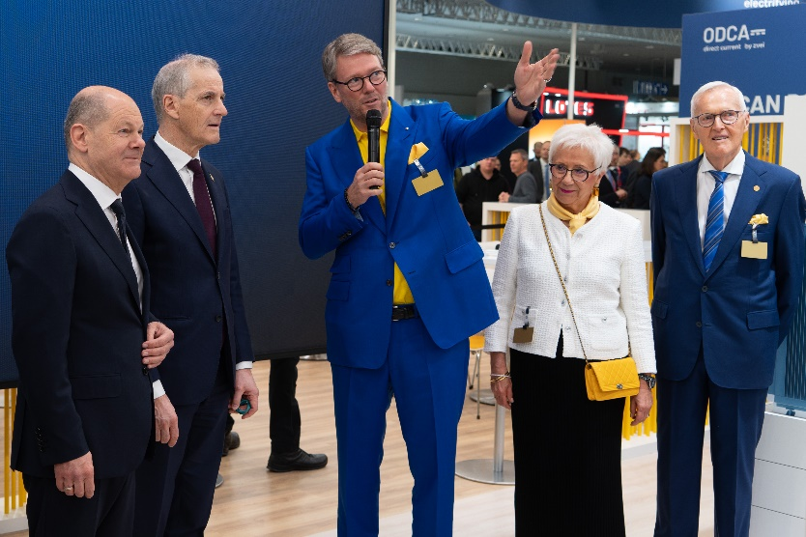

Caption: Philip Harting, CEO of the HARTING Technology Group, presents products for the All Electric Society together with senior managers Margrit and Dietmar Harting, the German Chancellor Olaf Scholz and the Norwegian Prime Minister Jonas Gahr Støre.

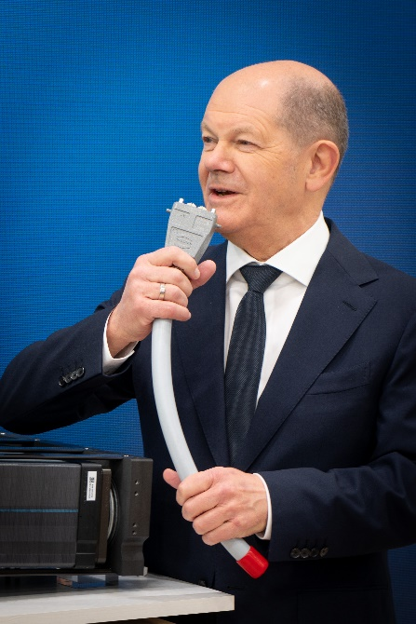

Caption: Fun at the trade fair stand: German Chancellor Olaf Scholz quickly turned the Han-Modular® connector from HARTING into a microphone.
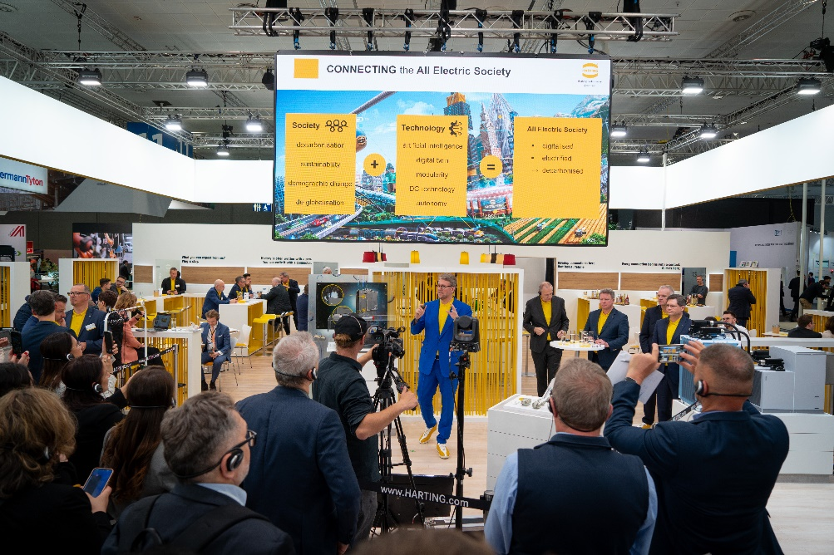

Caption: At the HARTING press conference, interested journalists were introduced to the mission statement "Connecting the All Electric Society" and the current product highlights.

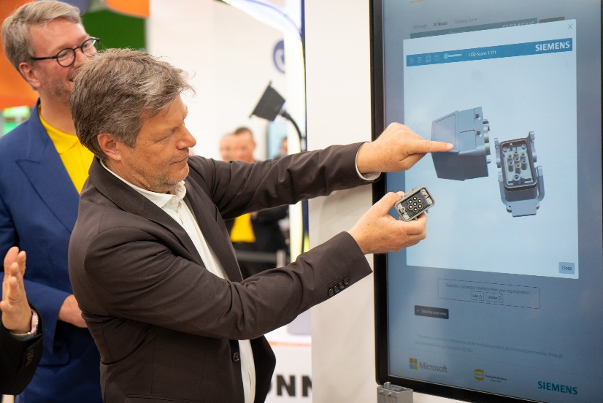

Caption: Vice Chancellor Robert Habeck visits the HARTING stand to find out about AI-supported development of connectors - a joint project by HARTING, Siemens and Microsoft.

About HARTING:
The HARTING Technology Group is a leading global provider of industrial connectivity. Around 6,200 employees are active across the globe in 44 sales companies, 15 production facilities and six development sites. HARTING connectivity solutions are used to transmit "data, signals and power" in numerous industrial sectors. Among others, in transportation, electromobility, renewable energy production, automation and mechanical engineering. In the 2022/23 business year the family owned and managed company generated sales of EUR 1,036 million.
Contact:
HARTING Stiftung & Co. KG
Detlef Sieverdingbeck
Managing Director
Corporate Communication & Branding

Marienwerderstr. 3
D-32339 Espelkamp

Phone: +49 5772 47-244
Detlef.Sieverdingbeck@HARTING.com
www.HARTING.com

