HARTING is THE link to a sustainable future

Espelkamp/Hanover, 17 April 2023 --- "Making The Difference": Under this guiding motto the HARTING Technology Group will be presenting solutions for a sustainable future at this year’s HANNOVER MESSE. During the press conference, the technology group informed about connectivity and cabling solutions for renewable and decentralised energy supply. Ecosystems for digitalisation and connectors enabling efficient and sustainable life cycles were also on the agenda.

The technology group expects this business year to confirm the record result of the last business year (1,059 million). While inflation has passed its peak, there is no overall relief in sight for the time being. Climate change, (de)globalisation, the new banking crisis and supply bottlenecks are just a few additional challenges that companies are facing. "However, they also offer us tremendous opportunities, due to the fact that they are driving topics such as digitalisation, renewable energies and decarbonisation forward," as Philip Harting, CEO of the technology group stated, after opening the press conference at the trade fair stand.

"Our solution to meeting the challenges and seizing the opportunities at hand: Innovative technologies! After all, THEY are what really make the difference," as Philip Harting continued. Specifically, the technology group has developed a concept for this: Connectivity+: In doing so, HARTING is examining the social megatrends and deriving technological megatrends from them. The technology group then develops concrete solutions and technologies accordingly on this basis. This year's results: At HANNOVER MESSE 2023, HARTING will be highlighting applications from the areas of "Connecting the Digital Twin", "Connecting New Energy" and "Excellence in Connectivity". In this context, the focus is firmly on sustainability – ranging from resource conservation and energy savings to the environmentally friendly production processes going on behind the scenes.

Innovations - but sustainable, please

Trend topics "Connecting the Digital Twin”
- The technology group is now presenting the SmEC - Smart Electrical Connector. It is the first connector with an active asset administration shell and forms the foundation of the digital twin. The connector records all process and condition data over the entire life cycle. The AAS acts as a digital twin for components, machines, plants and entire factories and can be used as desired through partial models. It ensures a consistent design and simplifies production planning, while also making the carbon footprint transparent and showing up savings measures. What’s more, digital documentation also saves millions of tonnes of paper.
- The Internet of Things (IoT) is about connecting real objects with their digital twins. This connection needs simple and miniaturised Ethernet communication, as offered by Single Pair Ethernet. At the trade fair, HARTING will be demonstrating 1Gbit SPE data transmission over more than 40 metres. But this technology not only bridges ever longer distances, it also saves up to 50 % of copper and weight, up to 25 % of space and about 1/3 of the plastics previously involved.
Trend topics "Connecting New Energy”
- Hydrogen is a great hope for the future when it comes to reducing CO2 emissions. At the fair, the technology group will be showcasing connectors and cable solutions for hydrogen charging.
- In addition, HARTING Connectivity+ will present solutions for the energy transition and transformation. Efficiency optimisation, the smooth and convenient integration of new technologies and reusability are crucial in this context. The Han® ORV3 Power Connector will be presented for the first time at this year’s event. The connector factors in the requirements of efficient power transmission in data centres and is geared to making them more efficient, more flexible and more quickly scalable.
- In the field of e-mobility, the technology group is working with the company ABB and is offering a charging device for racing cars in the Formula E racing class. Here, HARTING is supplying a customised charging cable for this purpose, which is also removable. This consists of a standard CCS2 charging connector on the vehicle side and a Han® HPR connector featuring a high-voltage modular solution on the infrastructure side. HARTING is also presenting its new high-performance DC charging connectors – an addition which significantly expands the technology group's current DC product portfolio for the American and European markets.
Trend topics "Excellence in Connectivity”
- The Han-Modular® Push-In is the latest addition to the core portfolio of the HARTING Technology Group and offers a combination of different connection techniques. It provides the necessary flexibility in the field, given that tool changes are quick, easy - and tool-free on top. Therefore it is suitable for scenarios in difficult and demanding environments, as on wind turbines, for example.
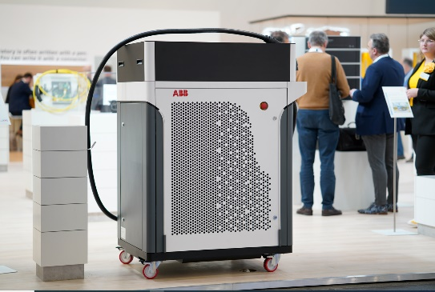

Caption: The ABB Power Charger features a HARTING charging solution with combined charging system and Han® Modular connection.

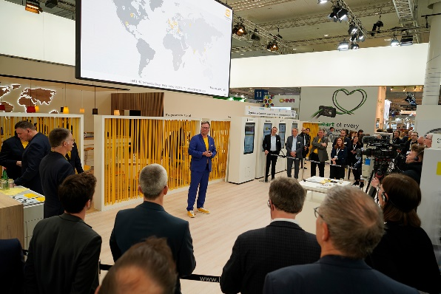

Caption: At the HARTING press conference, journalists learned more about sustainable products and solutions from the technology group.

About HARTING:
The HARTING Technology Group is a leading global supplier of industrial connectivity for the three lifelines "Data", "Signal" and "Power" with 14 production facilities and subsidiaries in 44 countries. Furthermore, the company also produces retail checkout systems, electromagnetic actuators for automotive and industrial series use, charging equipment for electric vehicles, as well as hardware and software for customers and applications in automation technology, mechanical and plant engineering, robotics and transportation engineering. Around 6,500 employees generated a turnover of 1,059 million euros in 2021/22.

Contact:
General Manager Corporate Communications & Branding (CCB)
Marienwerderstr. 3 32339 Espelkamp
Phone: 05772 47-244
Fax: +49 5772 47-400
Detlef.Sieverdingbeck@HARTING.com
More information at: www.HARTING.com

Contact:
HARTING Stiftung & Co. KG Tara-Luise Winkelmann
Professional Corporate Communication
Corporate Communication & Branding (CCB)
Marienwerderstr. 3
32339 Espelkamp - Germany
Phone: +49 5772 47-9447 TaraLuise.Winkelmann@HARTING.com
Further Information: http://www.HARTING.com

