Docking frame for flexible IP65/67 protected machine connections

Espelkamp, 14 November 2023 --- HARTING is expanding its range of docking frames with IP65/67 protected solutions available in the standard sizes for industrial connectors (6B to 24B). This allows machine modules as well as tools to be docked automatically – and entirely tool-free. A plug-in process or even hard wiring including cables can be dispensed with "blind mating" option.

A floating side of the docking frame as well as guiding elements provide the necessary flexibility and safety during the plugging process. When docked, the two halves of the housing form an interface. The docking frame can compensate for a lateral offset of 1 mm, while there is a clearance of 1.5 mm for safe and secure mating in the axial direction. After execution, an IP65/67 protected connection is created between the seals on both sides.
The IP65/67 docking frames can be used flexibly with Han® monoblocks and Han-Modular® modules. Complete, all-round protection of the interfaces is achieved with housings for rear mounting.

The advantages at a glance:
- Lower production and installation costs thanks to "blind mating" option
- Touch safe contacts streamline convenient installation
- High reliability thanks to protection class IP65/67
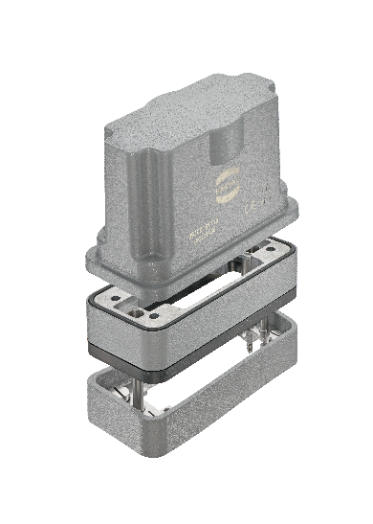

Captions: The IP65/67 docking frame enables straight-forward, automatic connection of machine modules – also in environments with harsh and demanding ambient conditions.
About HARTING:
The HARTING Technology Group is a leading global provider of industrial connectivity. Around 6,500 employees are active across the globe in 44 sales companies, 15 production facilities and six development sites. HARTING connectivity solutions are used to transmit "data, signals and power" in numerous industrial sectors. Among others, in transportation, electromobility, renewable energy production, automation and mechanical engineering. In the 2021/22 business year the family owned and managed company generated sales of EUR 1,059 million.

Contact:
HARTING Stiftung & Co. KG
Detlef Sieverdingbeck
General Manager
Corporate Communication & Branding (CCB)

Marienwerderstr. 3
D-32339 Espelkamp

Tel.: +49 5772 47-244
Detlef.Sieverdingbeck@HARTING.com

