New Ha-VIS eCon switches for robust single pair Ethernet

Espelkamp, 14 November 2023 --- HARTING has now launched the Ha-VIS eCon 4000 M12T1 SPE, a single pair Ethernet (SPE) switch with IP67 protection. The robust metal housing stands up to the adversities of harsh outdoor environments (tested for rail vehicles according to EN 50155) and enables secure data communication - also in challenging and demanding indoor industrial scenarios.
Transmission is protected against shock and vibration and is operational in a wide temperature range (-40 to +70 °C). The switch is extremely compact (191 x 60 x 42 mm), provides eight ports and comes in two different versions:
- The eCon 4017GBT-BXT features a Gigabit uplink to the Ethernet network (M12 X-coded) and integrates up to 7 SPE devices via 100BaseT1.
- The eCon 4035GBT-BXT has a Gigabit uplink, and provides five 100BaseT1 and two 1000BaseT1 ports as SPE interfaces.
The automatic master/slave configuration is a new feature for an unmanaged switch. On making the connection, the master and slave roles are automatically defined between the communication partners.
The Ha-VIS eCon 4000 M12T1 switches are ideal for application scenarios in rail vehicles, general vehicles and automation. In zones with demanding ambient conditions, they secure data transmission via Ethernet: these include applications in production lines, camera-based quality assurance, in passenger and driver information systems, as well as in video surveillance and ticketing systems.
The advantages at a glance:
- Future-proof thanks to integration of Single Pair Ethernet (SPE) in industrial networks
- Reliable data transmission given high shock and vibration resistance and wide temperature range
- Longer service life, as the units are protected against dust ingress and temporary submersion (IP67)
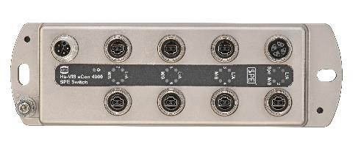

Captions: Ha-VIS eCon 4000 SPE switch featuring seven M12 T1 ports for the integration of SPE end devices in zones presenting harsh and challenging ambient conditions.
About HARTING:
The HARTING Technology Group is a leading global provider of industrial connectivity. Around 6,500 employees are active across the globe in 44 sales companies, 15 production facilities and six development sites. HARTING connectivity solutions are used to transmit "data, signals and power" in numerous industrial sectors. Among others, in transportation, electromobility, renewable energy production, automation and mechanical engineering. In the 2021/22 business year the family owned and managed company generated sales of EUR 1,059 million.

Contact:
HARTING Stiftung & Co. KG
Detlef Sieverdingbeck
General Manager
Corporate Communication & Branding (CCB)

Marienwerderstr. 3
D-32339 Espelkamp

Tel.: 0´+49 5772 47-244
Detlef.Sieverdingbeck@HARTING.com

