Technologies to take a look, touch and try out!
HARTING gives an outlook on HANNOVER MESSE and the future vision of an "All Electric Society" at its in-house trade press conference and subsequent HANNOVER MESSE Preview.

Espelkamp, 21 February 2024 --- Trade fair feeling and exclusive insights into current product highlights: The HARTING Technology Group made this possible for selected journalists as part of its trade press conference. For the general public, it's all about waiting and looking forward to HANNOVER MESSE 2024.

The journey from Asia, USA and Europe was worth it: this year, around 30 journalists from all over the world were treated to a pure trade fair feeling. In the HARTING Forum - the Technology Group's multimedia event location in Espelkamp - exhibits invited visitors to touch and try out the products. At the ZEA Green Energy biomethane plant in Uchte (owned by Board member Dietmar Harting) and the HARTING plant in Espelkamp, guests were able to take a look behind the scenes.

At the subsequent HANNOVER MESSE Preview, HARTING experts also presented the Technology Group's latest product highlights to around 100 interested journalists. This year's main theme of HANNOVER MESSE: "Energising a Sustainable Industry". In line with this, the focus is once again on topics such as sustainability and energy efficiency. For HARTING, the "All Electric Society" plays a key role. It describes a world in which energy requirements are covered by electricity. The energy for this is obtained from renewable resources. This was also reflected in the topics discussed at the HARTING trade press conference:

For the "All Electric Society", both the coupling of the sectors with each other and the networking within the sectors play a special role. Sectors stand for the areas of industry, energy, mobility and infrastructure. For energy and communication to flow within and across sectors, all areas must be interconnected.
- The presentation "Wiring the 'All Electric Society' - pluggable" focussed on the associated need for cabling solutions as "hardware". HARTING provides cabling solutions for this, ranging from standardised "plug-and-play" cables to complex, customised assemblies and distribution boxes. Applications in the distribution of hydrogen, in the railway sector and in industrial networks were shown as examples.
- The HARTING experts also explained that sector coupling in the "All Electric Society" can only succeed with high-performance Ethernet-based networks. For a successful energy transition, they bring growing data streams from Digital Twin and Co. safely to their destination. Standard Ethernet protocols play a key role for a global solution in the energy transition. HARTING supplies reliable connectivity and is actively involved in shaping standardisation for uniform standards.
- The technology group also supplies reliable connection technology for energy storage systems. Sustainable energy sources such as wind and solar are not available at all times, which is why energy storage options play a major role for the "All Electric Society".

"Digitalisation is largely responsible for the success of the electrification of our world. HARTING connection technology enables the associated networking of all areas," says Philip Harting, CEO, who is delighted with the HARTING Technology Group's contribution to a CO₂-neutral future.

HARTING has been demonstrably committed to environmental protection for more than 30 years and knows that everyone can make a contribution. Now it's time to roll up our sleeves and get started - "we can only move towards a climate-neutral future together," adds Harting.

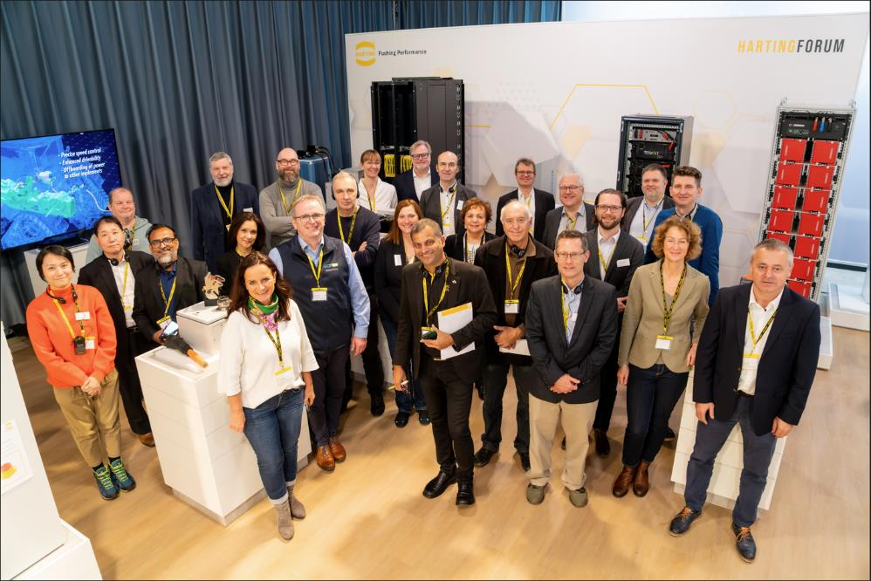

Caption: Take a look, touch, try out - around 30 journalists got up close and personal with the Technology Group's product highlights at the HARTING trade press conference.

About HARTING:
The HARTING Technology Group is a leading global provider of industrial connectivity. Around 6,200 employees are active across the globe in 44 sales companies, 15 production facilities and six development sites. HARTING connectivity solutions are used to transmit in numerous industrial sectors. Among others, in transportation, electromobility, renewable energy production, automation and mechanical engineering. In the 2022/23 business year the family owned and managed company generated sales of EUR 1,036 million.

Contact:
HARTING Stiftung & Co. KG
Detlef Sieverdingbeck
General Manager
Corporate Communication & Branding
Marienwerderstr. 3
32339 Espelkamp - Germany

Tel.: +49 5772 47-244
Detlef.Sieverdingbeck@HARTING.com
More information: www.HARTING.com

