Faster wall-mounting for connectors
Fully EMC-shielded and highly robust outdoor housings can now be rear-mounted
Espelkamp / Hanover, April 12, 2021 --- The metal housings in the Han® EMV and Han® HPR series are now also available in versions that enable contact inserts to be mounted from the rear -- an option that simplifies the placement of interfaces on switch cabinet walls and increases the installation speed and thus lowers costs in the long term.
HARTING has produced other connector types that feature a rear-fit mounting option. The Han-Eco® A and B and the Han® B and Han® M series came out with this installation option (“Rear-Fit”) over the past two years. Now, the option is also available for the first time for the Han® EMV and Han® HPR series.

Rear-fit mounting means that contact inserts can be installed in the housing from the rear, which is particularly important for installation in cabinets in combination with prefabricated cable assemblies. Assembling both products is further accelerated by using a mounting frame -- or the modules can be inserted directly into the housing. All Han® series that feature the Rear-Fit option make it easier to install contact inserts and cut installation times.
The “Rear-Fit” housings are also interoperable with earlier versions that cannot be equipped from the rear, which translates into cost-effective, step-by-step introduction of the new housings into production.
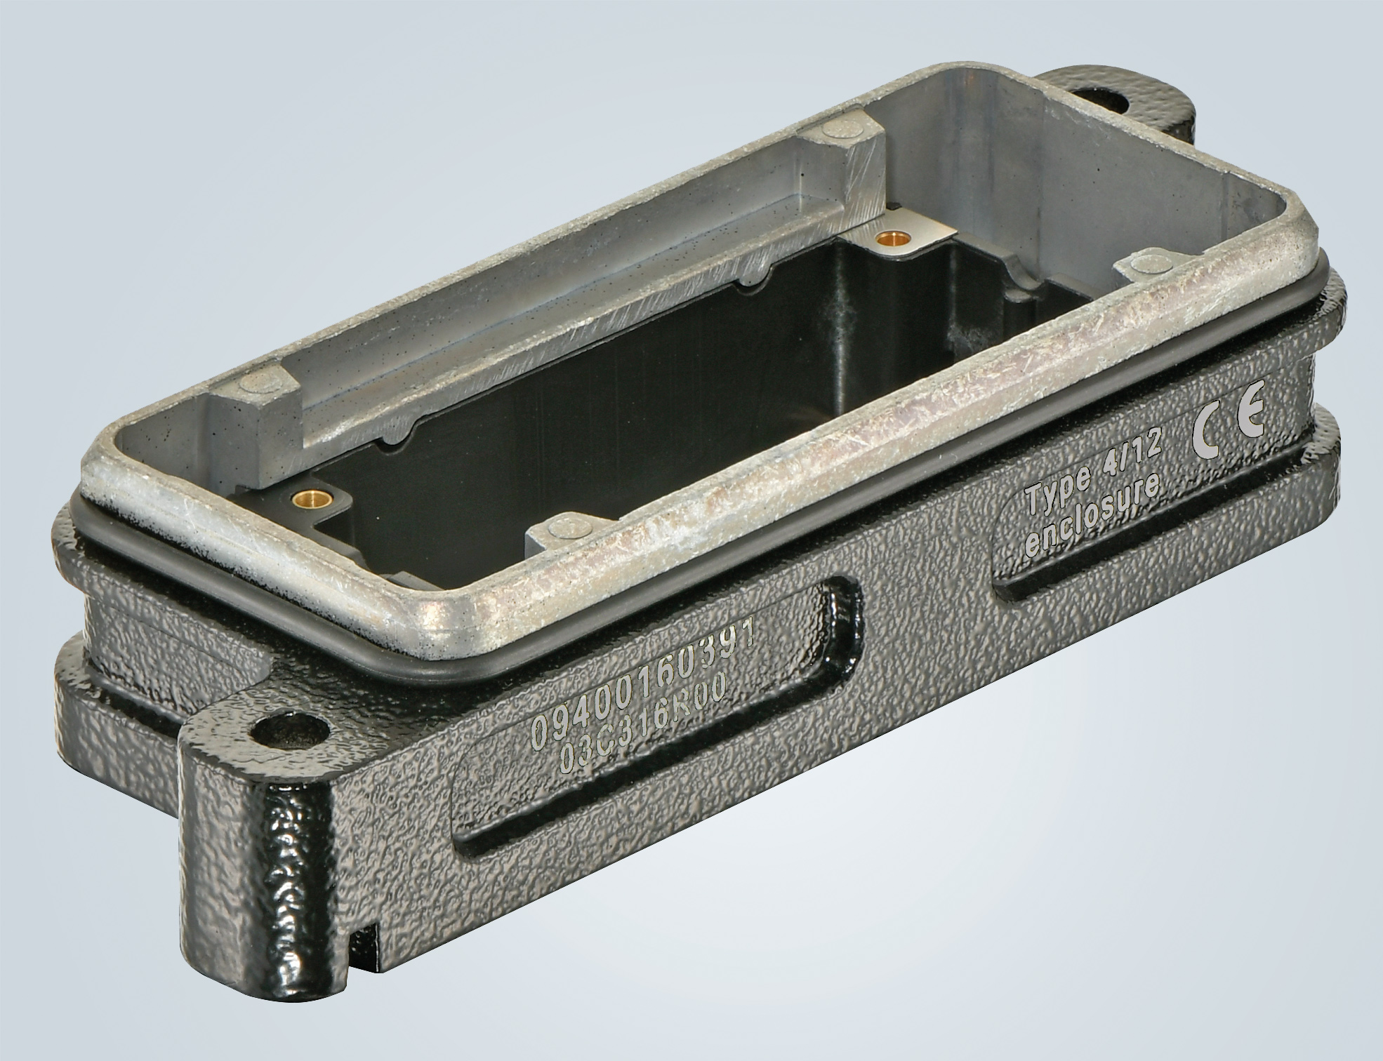Caption: Han® HPR 16 B add-on housing, into which the inserts can be locked from behind.
Further information:
www.HARTING.com/DE/en-gb/news/press-release

About HARTING:
The HARTING Technology Group is one of the world's leading providers of industrial connection technology for the three lifelines of Data, Signal and Power and has 14 production plants and 44 sales companies. Moreover, the company also produces retail checkout systems, electromagnetic actuators for automotive and industrial series use, charging equipment for electric vehicles, as well as hardware and software for customers and applications in automation technology, mechanical and plant engineering, robotics and transportation engineering. In the 2019/20 business year, some 5,500 employees generated sales of EUR 759 million.
Contact:
HARTING Stiftung & Co. KG
Detlef Sieverdingbeck
General Manager
Corporate Communication & Branding (CCB)
Marienwerderstr. 3
32339 Espelkamp
Tel.: 05772 47-244
Fax: 05772 47-400
Detlef.Sieverdingbeck@HARTING.com
More information at: www.HARTING.com

