Han® L32 B offers optimal use of installation space
The new Han® L32 B size lets HARTING offer more flexibility when selecting the right rectangular connector for industrial applications
Espelkamp / Hanover, April 12, 2021 --- Using an L32 B connector allows users to replace two size 16 B interfaces -- saving over 40% of installation space. This makes it possible to transmit power, signals and data with fewer interfaces and fewer components. It also cuts the time required to assemble interfaces. The resulting lower weight also benefits a number of other applications, e.g. in robotics. The solution not only saves space, it also makes a contribution to lower consumption - and thus stands for sustainable product design.
The space in the Han® L32 B housing can be filled with a Han E® insulator for 32 contacts (16 A / 500 V) or with a Han-Modular® articulated frame that can accommodate up to eight modules. As a result, the new size not only offers space for the articulated frame with the most module slots -- it also results in the highest module density in a connector. Over 100 Han-Modular® modules means that users can put together the optimal interface for virtually any application.
The Han® L32 B format offers a wide range of housing variants: sleeve housings with a straight or lateral cable outlet can be combined with bulkhead-mounted housings, bulkhead socket housings or coupling housings, with the customer given the choice between Han-Easy Lock® transverse brackets and side brackets made of metal. Matching cable glands are available in sizes M40, M50 and Pg29. Housings are equipped with a cap that protects the mounting side when it is not plugged in.
One of the first applications of the L32 B is use in the power supply of an injection moulding machine, where the housing is equipped with Han E® inserts. In the automotive industry, the L32 B is additionally teamed with Han® pneumatic modules in order to transmit compressed air in minimal installation space.
At 57 mm, the L32 B housing is exactly 25 mm wider than the next smaller size of 24 B. The new addition means that HARTING now offers a total of seven sizes for the Han® B: 6, 10, 16, 24, 32, L32 and 48. This facilitates the optimal use of installation space in different applications.
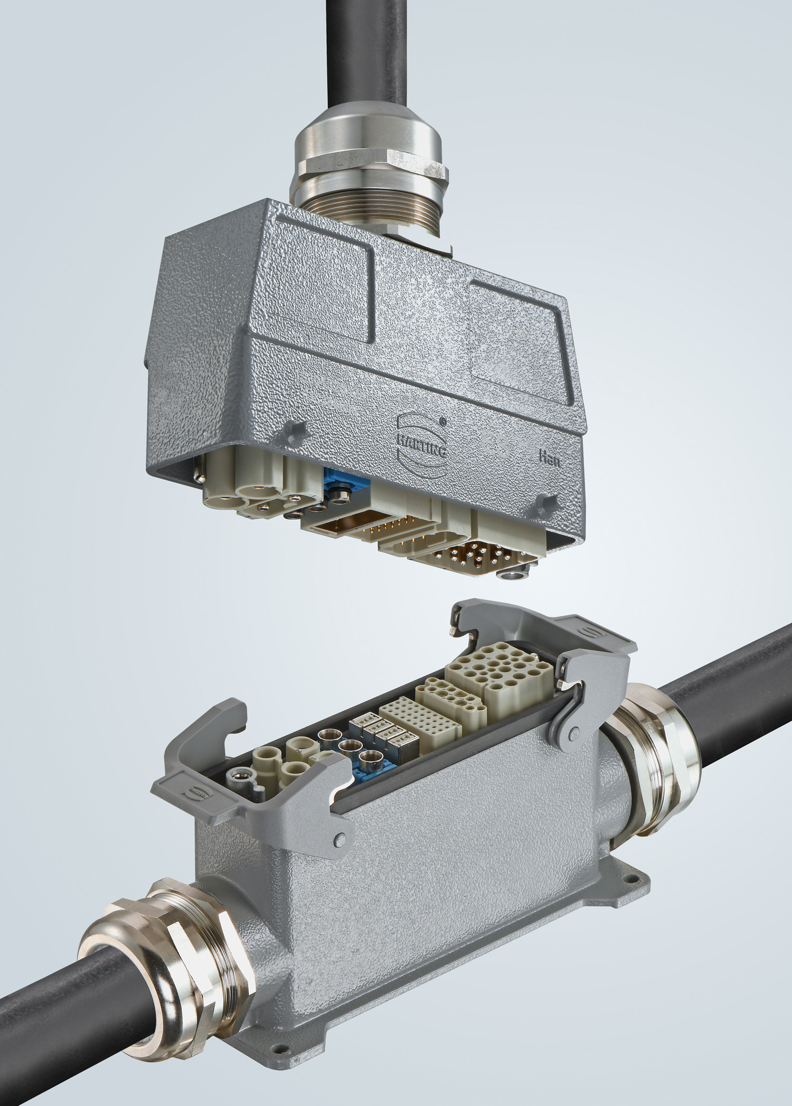
Caption: The products for the Han® L32 B size with sleeve and bulkhead housings, Han® E contact inserts and articulated frames.
Further information:
www.HARTING.com/DE/en-gb/news/press-release

About HARTING:
The HARTING Technology Group is one of the world's leading providers of industrial connection technology for the three lifelines of Data, Signal and Power and has 14 production plants and 44 sales companies. Moreover, the company also produces retail checkout systems, electromagnetic actuators for automotive and industrial series use, charging equipment for electric vehicles, as well as hardware and software for customers and applications in automation technology, mechanical and plant engineering, robotics and transportation engineering. In the 2019/20 business year, some 5,500 employees generated sales of EUR 759 million.

Contact:
HARTING Stiftung & Co. KG
Detlef Sieverdingbeck
General Manager
Corporate Communication & Branding (CCB)
Marienwerderstr. 3
32339 Espelkamp
Tel.: 05772 47-244
Fax: 05772 47-400
Detlef.Sieverdingbeck@HARTING.com
More information at: www.HARTING.com

