New Han® modules for compressed air, energy storage and Ethernet
Greater capacity, less weight
Espelkamp / Hanover, April 12, 2021 --- In the Han-Modular® series, HARTING offers numerous connectors with which the energy efficiency of machines and systems can be sustainably increased. The latest example of this is the Han® 300 A module. It fits in with the classic development goal for energy storage systems by enabling more capacity with less weight. Today's energy storage systems often work with outputs of 200 A / 800 V DC. Future applications with higher energy density will require transmissions of 300 A / 1200 V DC and more. The Han® 300 A module is the matching interface.
The Han® 300 A module is suitable for connecting new energy storage units, as well as for upgrading existing systems (being plug-in compatible with the Han® 200 A module). Equipped with touch-safe contacts, it can be connected directly to the busbar or integrated into storage drawers.
The M12 connector format is new to the Han-Modular® range. Two connectors, either X- or D-coded, each fit into one module. In this way, for example, it is possible to integrate 10 Gbit/s Ethernet into a modular interface in a particularly compact, space-saving manner. By comparison with conventional RJ45 solutions, the M12 interface is significantly more robust. All common bus systems can be easily adapted, including Profibus, Profinet, CAN, Ethernet Cat. 5 and Cat. 6A.
The trends towards greater digitization and modularization will also continue to grow:The Han® Shielded Power Module represents a space-saving and easy-to-maintain alternative to hard-wired shielded power cables. The module features three power contacts (16 A/400 V) and is suitable for connecting frequency-controlled drives, for example. Moreover, the series has also been supplemented with an EMC-protected module for signal transmission: with a large-area shield transfer and a 360° shield plate, the Han® Shielded Module Basic not only offers good shielding, it also enables a great deal of transmission in a compact installation space. Up to 27 shielded D-Sub contacts with 4 A/32 V can be plugged in.
There are already several solutions for 360° shielded data transmission in the Han-Modular® programme, including the Han® Megabit module, among others. A new feature, however, is an adapter for the module that allows it to be plugged onto printed circuit boards. The module features 8 data pins and a shield contact and enables Ethernet transmission with two lines according to Cat. 5 or with one line according to Cat. 6A.
Introducing the Han® Pneumatic Double Module, a new HARTING connector for compressed air transmission will be launched in the current quarter. The contacts of the interface have a larger connection range of 8 or 10 mm. This enables the design of compressed air transmission with sufficient capacity to operate valve terminals for various consumers.
What’s more, the double module is also easy to assemble: A push-in solution using the proven quick connection technology and alternatively a conventional pneumatic connection are available for the hose connection. The combination can be inserted into the module – tool-free. With this module, HARTING is now further expanding its range of compressed air interfaces: Systems with internally and externally calibrated pneumatic tubing of 3, 4, 6, 8 or 10 mm can now be reliably installed with the help of pneumatic modules.
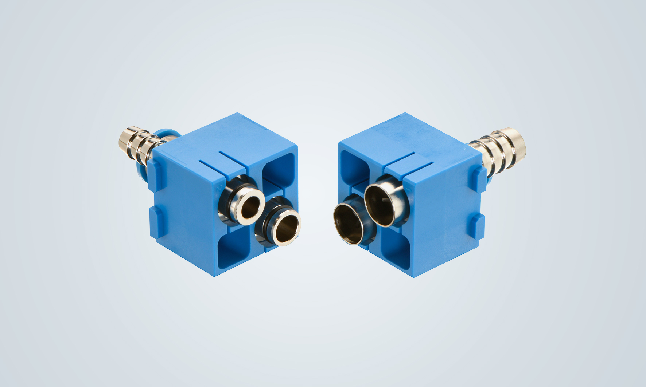
Caption: Han-Modular® pneumatic double module for the installation of powerful compressed air networks in industrial connectors.
Further information:
www.HARTING.com/DE/en-gb/news/press-release
About HARTING:
The HARTING Technology Group is a leading global supplier of industrial connectivity technology for the three lifelines "Data", "Signal" and "Power" with
14 production facilities and subsidiaries in 44 countries. The company also manufactures checkout zones for the retail trade, electromagnetic actuators for automotive and industrial series production, charging equipment for electric vehicles, as well as hardware and software for customers and applications in automation technology, mechanical and plant engineering, robotics and the transportation sector, among others. Around 5,500 employees generated a turnover of 759 million euros in 2019/20.

Contact:
HARTING Stiftung & Co. KG
Detlef Sieverdingbeck
General Manager
Corporate Communication & Branding (CCB)
Marienwerderstr. 3
32339 Espelkamp
Tel.: 05772 47-244
Fax: 05772 47-400
Detlef.Sieverdingbeck@HARTING.com
More information at: www.HARTING.com

