Han® S gives users a complete cable assembly
Prefabricated interfaces for energy storage devices reduce on-site wiring costs
Espelkamp / Hanover, April 12, 2021 --- Energy efficiency is a topic that HARTING is concerned with and for which the technology group offers specific solutions: With its Han® S, HARTING has developed a series of connectors that enable customers to build energy storage systems on the basis of battery modules. The Han® S is also the first HARTING-developed connector specifically designed for front-mounting energy storage systems. In order to shorten installation times even more and reduce the amount of wiring required on site, HARTING is now offering the interfaces in combination with fully prefabricated cable assemblies tailored to the respective application.
The assemblies are the Han® S 200 CA-c-b/r 25², CA-c-b/r 35² and CA-c-b/r 50 mm², and are available with cable lengths of 20 cm, 30 cm, 40 cm and 50 cm. They are suitable for temperatures ranging between -50 and +120 degrees C°. The fabrication material is halogen-free as well as ozone-resistant. The voltage limits are 1.8 kV (25 mm²) - 3 kV (50 mm²) AC and 2.7 (25 mm²) - 4.5 kV (50 mm²) DC. The Han® S assemblies meet various standards, including EN 45545-2 and NF F 16-101.
Han® S offers optimal safety for the construction of battery storage systems since its design meets all technical requirements -- including the new UL 4128 standard for stationary energy storage systems, currently the highest standard the market requires.
Finger-protected contacts mean safe installation
The single-pin connector is well-suited for front-mounting drawers on energy storage devices and can transmit rated currents of up to 200 A at 1500 V. The connector ensures safe installation thanks to finger-protected contacts with various types of connection (M8 bolts or busbars) and permits users to visually check the locking status. In addition, the product is vibration-proof and comes in two different colours, red (+) and black (-). The Han® S features a mechanical coding system that makes it impossible to incorrectly connect the polarity. This feature makes the new connector an ideal solution for connecting large numbers of battery modules.
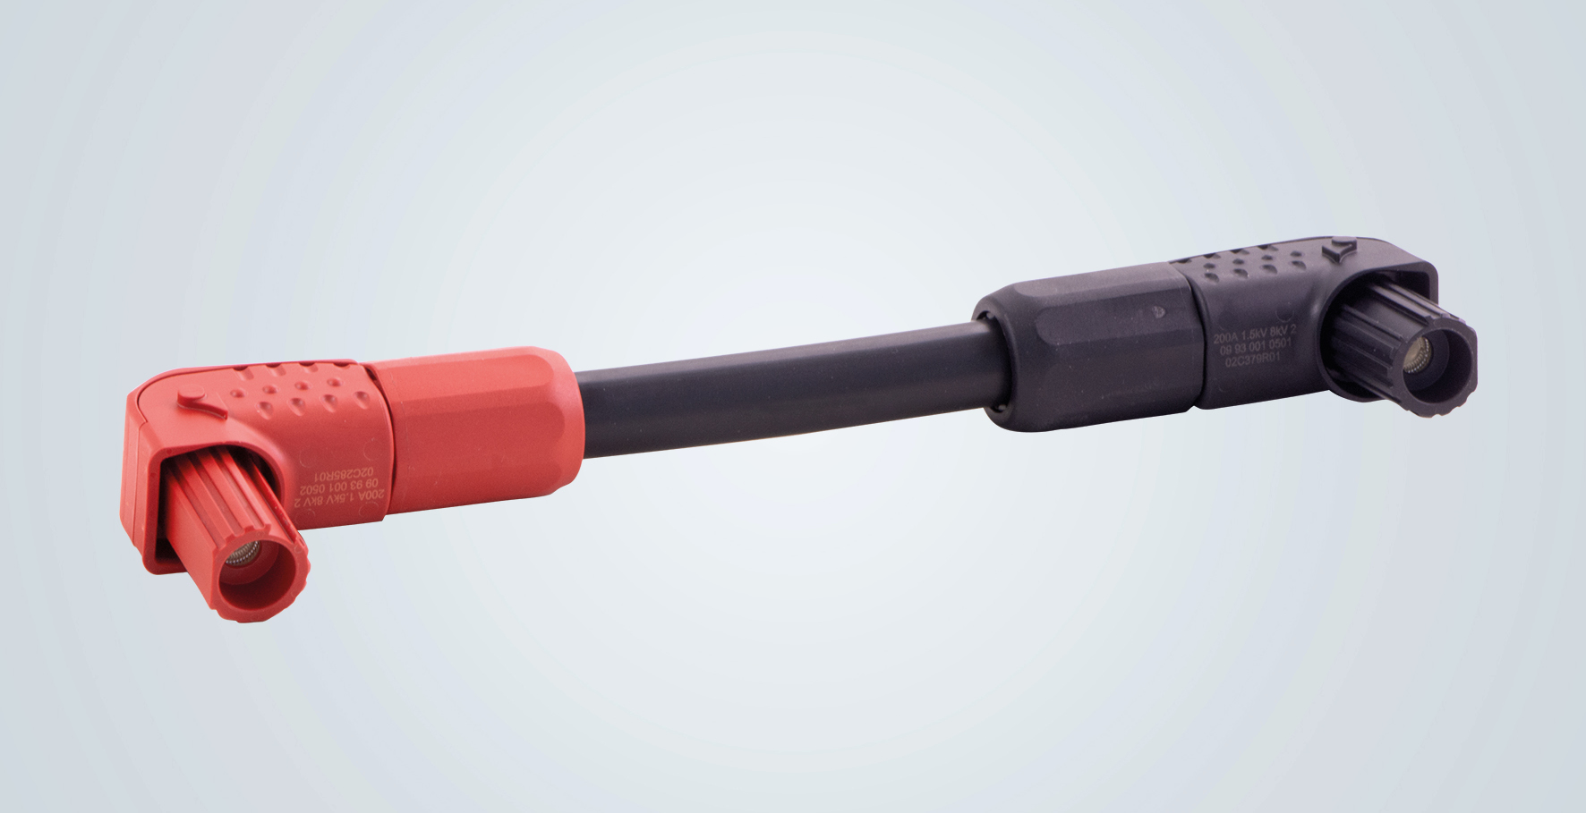
Caption: Using Han® S connectors gives you a cable assembly that can be immediately used.
Further information:
www.HARTING.com/DE/en-gb/news/press-release

About HARTING:
The HARTING Technology Group is one of the world's leading providers of industrial connection technology for the three lifelines of Data, Signal and Power and has 14 production plants and 44 sales companies. Moreover, the company also produces retail checkout systems, electromagnetic actuators for automotive and industrial series use, charging equipment for electric vehicles, as well as hardware and software for customers and applications in automation technology, mechanical and plant engineering, robotics and transportation engineering. In the 2019/20 business year, some 5,500 employees generated sales of EUR 759 million.

Contact:
HARTING Stiftung & Co. KG
Detlef Sieverdingbeck
General Manager
Corporate Communication & Branding (CCB)
Marienwerderstr. 3
32339 Espelkamp
Tel.: 05772 47-244
Fax: 05772 47-400
Detlef.Sieverdingbeck@HARTING.com
More information at: www.HARTING.com

