A smart infrastructure charting the course to the IIoT
Our reliable “All for Ethernet” solutions for industrial applications

Espelkamp, 23 November 2021 --- Digitalisation is advancing uniformly networked corporate processes in development, production and sales. Presenting appropriate and expedient infrastructure solutions for easy access to the IIoT, HARTING is factoring in the current trends and developments shaping the industrial transformation. Connector innovations such as the RJ Industrial® MultiFeature, preLink® RJ45 as well as the T1 Industrial interface for Single Pair Ethernet according to IEC 63171-6 in M12 and M8 housings are playing a special role.
Ethernet is being deployed in more and more areas of automation and is the connecting element for IT and OT (Operational Technology). In order to be able to implement correspondingly robust networks for industrial use, HARTING is constantly developing and refining its range of reliable Industrial Ethernet connectivity. With regard to Fast Ethernet and Gigabit Ethernet, the Technology Group is highlighting new variants of the robust RJ Industrial® Multifeature interface: the industrial RJ45 with "integrated side cutter" for accelerated and simplified cable connection, as well as the new preLink® RJ45 in optimised design. Both RJ45 innovations are decidedly convincing in their straight and angled versions.
Catering to demanding Ethernet applications on the field level, where assembly can be subject to massive time pressure, HARTING is now presenting M12 circular connectors according to the new IEC 61076-2-010 standard. This represents the cross-market PushPull locking standard for M12 connectors that users have long been waiting for. On the one hand, this allows access to standing and recessed device sockets, while on the other hand, the interfaces can also be connected 75% faster in the field. Consequently, the long-standing critical issue of second source and interoperability has been overcome.
Users of PROFINET-compatible cabling solutions should take a good look at the miniaturised ix Industrial® connector. Compared to RJ45 solutions, the 70% smaller interface is now also specified in the PROFINET Guideline Cabling and Interconnection Technology and offers users a significantly more compact, robust and absolutely industry-compatible interface for demanding applications in the PROFINET environment.
Moreover, among the innovations, the new variants of the T1 industrial interface for single pair Ethernet are also playing a special role, most particularly the interface standardised according to IEC 63171-6 in M12 and M8 housings. In addition, the technology group will be presenting the new hybrid concepts for SPE plus Power according to IEC 63171-7. In order to meet power requirements beyond the possible 50W of Power over Data Line, the -7 standard for hybrid SPE solutions represents an important step.
Pursuing the aim of making SPE technology accessible to further industrial application areas, the Technology Group has now made the first solutions for single-pair connection via PCB terminal available. Terminals simplify the connection of SPEs to an even greater extent, and can help to bring Ethernet to the field level and simplify handling. This is particularly interesting within the context of SPE and IIoT with low data rates from 10 Mbit/s and transmission lengths of up to 1000 m in industry, building and process automation.
SPE Industrial Partner Network
HARTING's role as a founding member of the SPE Industrial Partner Network e.V. is also visibly communicated to the outside world. Application examples for SPE will be shown as part of our digital offering – interested parties are cordially invited to ask their questions about SPE.

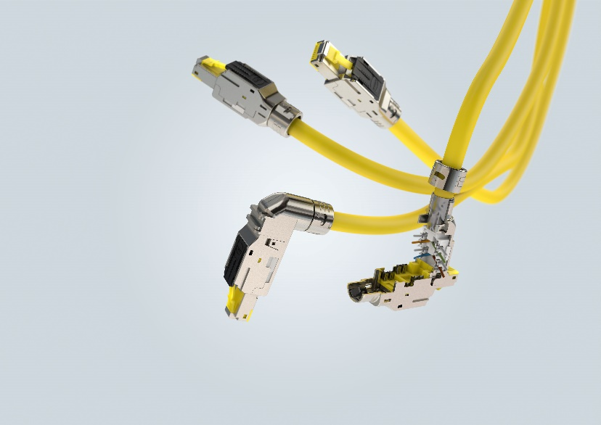
Caption: The RJ Industrial®MultiFeature is a significantly improved version of the classic RJ45.

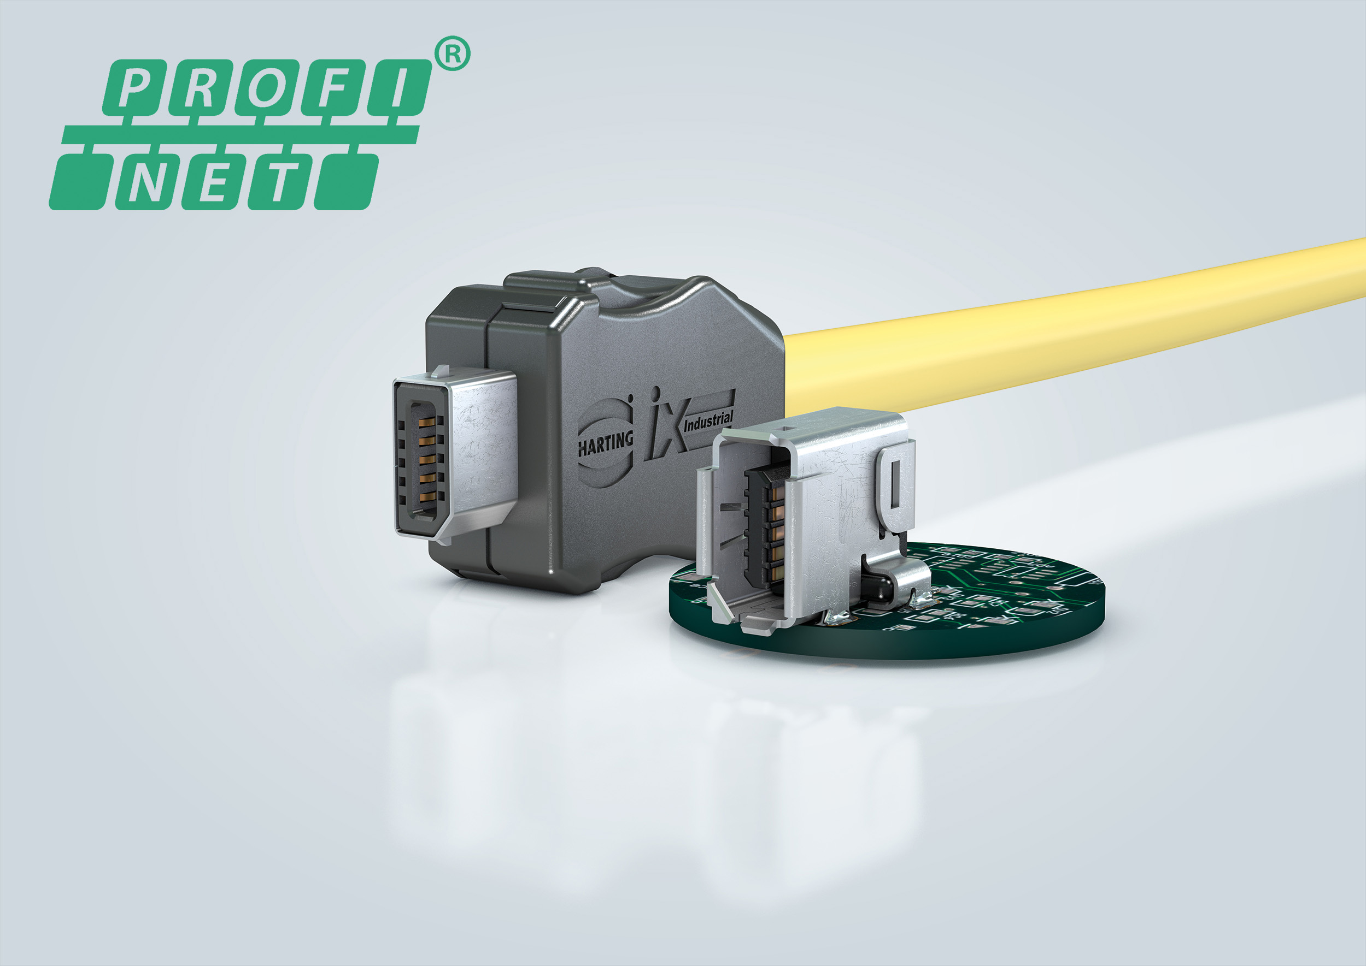
Caption: The ix Industrial® - 70% more compact by comparison with RJ45 solutions and now also PROFINET specified.

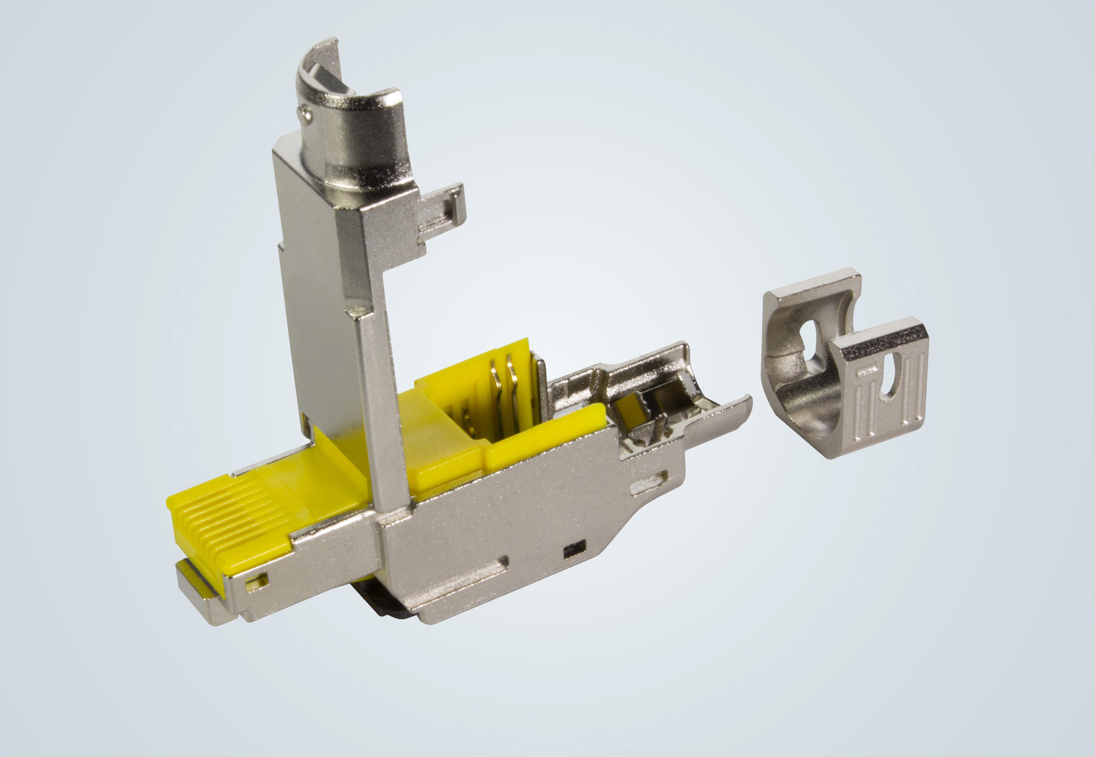

Caption: The new preLink® RJ45 features an optimised design.

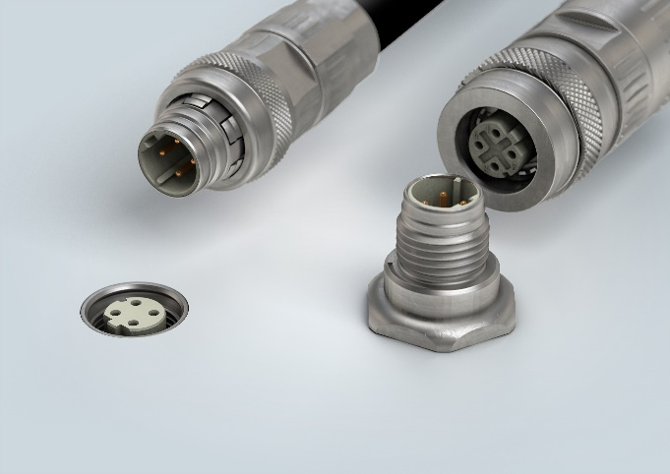

Caption: M12 PushPull circular connectors according to the new IEC 61076-2-010 standard.

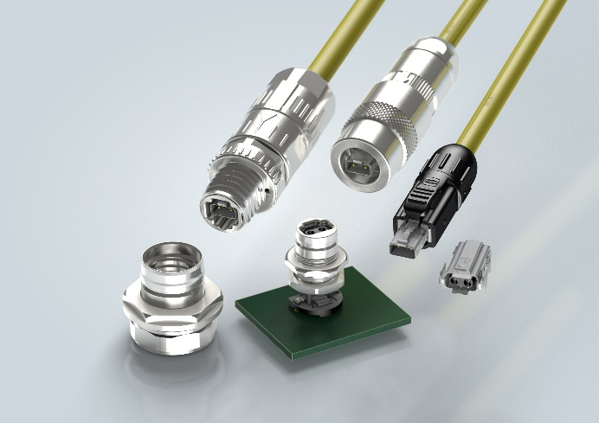
Caption: The new variants of the T1 Industrial Interface for Single Pair Ethernet.

About HARTING:
The HARTING Technology Group is one of the world's leading providers of industrial connection technology for the three lifelines of Data, Signal and Power and has 14 production plants and 44 sales companies. Moreover, the company also produces retail checkout systems, electromagnetic actuators for automotive and industrial series use, charging equipment for electric vehicles, as well as hardware and software for customers and applications in automation technology, mechanical and plant engineering, robotics and transportation engineering. In the 2019/20 business year, some 5,500 employees generated sales of EUR 759 million.
Contact:
HARTING Stiftung & Co. KG
Detlef Sieverdingbeck
General Manager
Corporate Communications & Branding (CCB)
Marienwerderstr. 3

32339 Espelkamp

Tel.: 05772 47-244
Fax: 05772 47-400
Detlef.Sieverdingbeck@HARTING.com
More information at www.HARTING.com

