M12 Push-Pull: Fast locking systems save valuable installation time in automation / IEC 61076-2-010 first international standard for M12 fast locks / outer and inner locks available

Espelkamp/Hanover, 30 May 2022 --- Installation time is a considerable cost factor in assembly. Fast locks based on the push-pull principle save up to 90% here by comparison with traditional screw locks for M12 circular connectors. For the first time, the new IEC 61076-2-010 standard now provides an internationally uniform definition for the locking mechanism for M12 connectors for vertical and recessed device sockets. It is also possible to connect flying cable couplings.
The time factor is crucial when setting up automation applications. Deadlines must be met, and costs must not get out of hand. In order to provide expedient support for installers, automation engineers should use devices fitted with reliable fast-locking mechanisms for connecting data, signals and power. HARTING offers connectors with push-pull locking for this time-saving alternative. Interfaces can be connected and disconnected rapidly and reliably by simply pushing or pulling the housing. Unlike screwed solutions, no torques need to be checked and no tools used. Regardless of whether it’s a traditional RJ45, USB or circular connector – push-pull fast locks save installers valuable time when setting up their application.

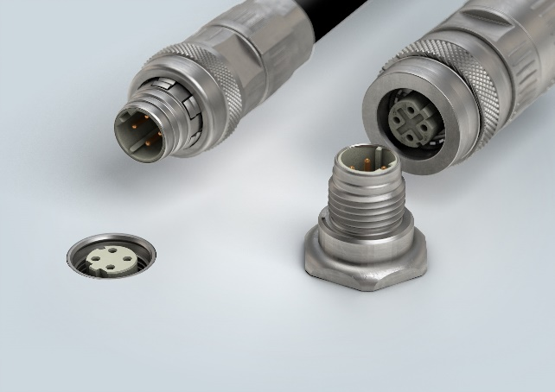
Caption: Push-pull locks to IEC 61076-2-010 offer up to 90% savings in time by comparison with threaded connections.

For further information, please go to:
www.HARTING.com/DE/en-gb/news/press-release

About HARTING:
The HARTING Technology Group is one of the world's leading providers of industrial connection technology for the three lifelines of Data, Signal and Power and has 14 production plants and 44 sales companies. Moreover, the company also produces retail checkout systems, electromagnetic actuators for automotive and industrial series use, charging equipment for electric vehicles, as well as hardware and software for customers and applications in automation technology, mechanical and plant engineering, robotics and transportation engineering. In the 2020/21 business year, some 6,000 employees generated sales of EUR 869 million.

Contact:
HARTING Stiftung & Co. KG
Detlef Sieverdingbeck
General Manager
Corporate Communication & Branding (CCB)
Marienwerderstr. 3
32339 Espelkamp - Germany
Tel.: +49 5772 47-244
Fax: +49 5772 47-400
Detlef.Sieverdingbeck@HARTING.com
More information at: www.HARTING.com

