Single Pair Ethernet (SPE): T1 Industrial Style interface available in M12 housing / space-saving, resource-protecting infrastructure ready for the field / IP65/67 protection and optimal screening for secure transmission from the cloud to the sensor

Espelkamp / Hanover, 30 May 2022 --- Seamless Ethernet communication via data networks from the cloud to the sensor/actuator level describes nothing less than the implementation of Industry 4.0. The T1 Industrial Style interface to IEC 63171-6 is also available in a sturdy M12 housing with immediate effect.
End-to-end Ethernet from the cloud to the sensor has not been economically viable to date given the lack of suitable infrastructure. Single Pair Ethernet has now closed that gap. The significant reduction in cables and connectors saves space, spares resources and facilitates applications in the field that were previously only possible with traditional signal wiring. SPE can accommodate significantly more sensors, thereby enabling more data to be captured from the field. As a result, operators can obtain a much more detailed picture of their processes and are much better placed to make improvements.
With immediate effect, HARTING is also offering its T1 Industrial Style interface, to the international standard IEC 63171-6, also in a sturdy M12 fully metal housing. With IP 65/67 protection and reliable 360° screening, SPE can now be deployed in challenging environments.
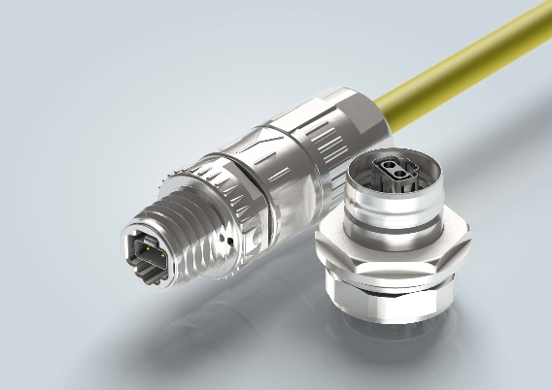

Caption: Bringing IIoT to the field – T1 Industrial Style, available with immediate effect in sturdy M12 housing

For further information, please go to:
www.HARTING.com/DE/en-gb/news/press-release

About HARTING:
The HARTING Technology Group is one of the world's leading providers of industrial connection technology for the three lifelines of Data, Signal and Power and has 14 production plants and 44 sales companies. Moreover, the company also produces retail checkout systems, electromagnetic actuators for automotive and industrial series use, charging equipment for electric vehicles, as well as hardware and software for customers and applications in automation technology, mechanical and plant engineering, robotics and transportation engineering. In the 2020/21 business year, some 6,000 employees generated sales of EUR 869 million.

Contact:
HARTING Stiftung & Co. KG
Detlef Sieverdingbeck
General Manager
Corporate Communication & Branding (CCB)
Marienwerderstr. 3
32339 Espelkamp - Germany
Tel.: +49 5772 47-244
Fax: +49 5772 47-400
Detlef.Sieverdingbeck@HARTING.com
More information at: www.HARTING.com

