har-modular®: Modules for power, signals and data freely combinable /
Over a billion possible combinations / Can be ordered from a quantity of 1 / Online configurator delivers individual design data
Espelkamp / Hanover, 30 May 2022 --- In today’s industrial arena, devices and equipment is being developed in ever shorter cycles. The design and routing of circuit boards are becoming more sophisticated, posing a challenge to developers in search of the right solutions for all data, signals or power to be transmitted. To facilitate developers’ work, HARTING is offering a solution in the shape of har-modular® that provides a completely new level of flexibility for circuit boards.
har-modular® is a modular system which - in terms of size and architecture - is based on the DIN 41612 terminal strips that have been in use for many decades. Instead of relying on a large number of rigid solutions to date, har-modular® uses an online configurator to offer a building block consisting of various modules for the transmission of all important lifelines.
Developers can compile the modules required for power, signals and data individually in the online configurator. This personal solution can subsequently be ordered as from batches of 1, and the developer will also receive all the necessary data for their design-in.
In this way, prototypes can be very quickly, cost-effectively and flexibly assembled, while series production with har-modular® is also no problem. A flexible concept of this kind is totally new in the market and underlines HARTING’s aspiration to lead the way in the development of new, innovative concepts.

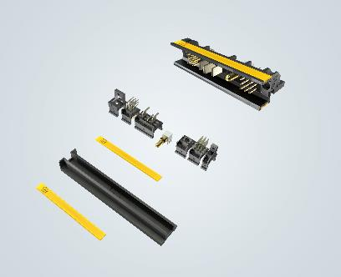
Caption: har-modular® is a modular principle: The various modules can be combined in over a billion different ways.

For further information, please go to:
www.HARTING.com/DE/en-gb/news/press-release

About HARTING:
The HARTING Technology Group is one of the world's leading providers of industrial connection technology for the three lifelines of Data, Signal and Power and has 14 production plants and 44 sales companies. Moreover, the company also produces retail checkout systems, electromagnetic actuators for automotive and industrial series use, charging equipment for electric vehicles, as well as hardware and software for customers and applications in automation technology, mechanical and plant engineering, robotics and transportation engineering. In the 2020/21 business year, some 6,000 employees generated sales of EUR 869 million.

Contact:
HARTING Stiftung & Co. KG
Detlef Sieverdingbeck
General Manager
Corporate Communication & Branding (CCB)
Marienwerderstr. 3
32339 Espelkamp - Germany
Tel.: +49 5772 47-244
Fax: +49 5772 47-400
Detlef.Sieverdingbeck@HARTING.com
More information at: www.HARTING.com

