Han® HPR Compact
Space-saving and powerful outdoor solutions

Espelkamp / Hanover, 30 May 2022 - Han® HPR is a globally recognised standard for connector housings that require special protection against environmental influences whether applied in power generation plants, rail vehicles or ships. Aiming to expand the connector range for harsh environments with limited installation space, HARTING is currently adding the “Han® HPR Compact” hoods and housings to the series.

They require 20 % less installation space and are 25 % lighter than conventional solutions. The product is available in sizes 6, 10, 16 and 24 B and has a special feature that enables the housings “to grow with demand”, even after installation. For this purpose, up to two extenders, each three centimetres high, are attached to the bulkhead mounted housing. Even in difficult locations, this solution offers enough space for a connector interface. Due to the savings in installation space and weight, Han® HPR Compact housings also contribute towards sustainability and are considered by HARTING as Connectivity+ because, for example, in the railway sector, every kg of weight counts for energy consumption.

The Han® HPR Compact offers the following benefits compared to previous solutions:
- Smaller mounting dimensions
- High flexibility due to the use of extenders (not more than two at a time), each adding 3 cm of height
- Time savings: shorter installations in environments with limited space
- 16 coding options allow safe mating process even in environments with limited space
- The entire Han® B compatible connector portfolio can be used, from standard inserts to Han® HC Modular, except for the insulation body of Han® HC 650 Modular

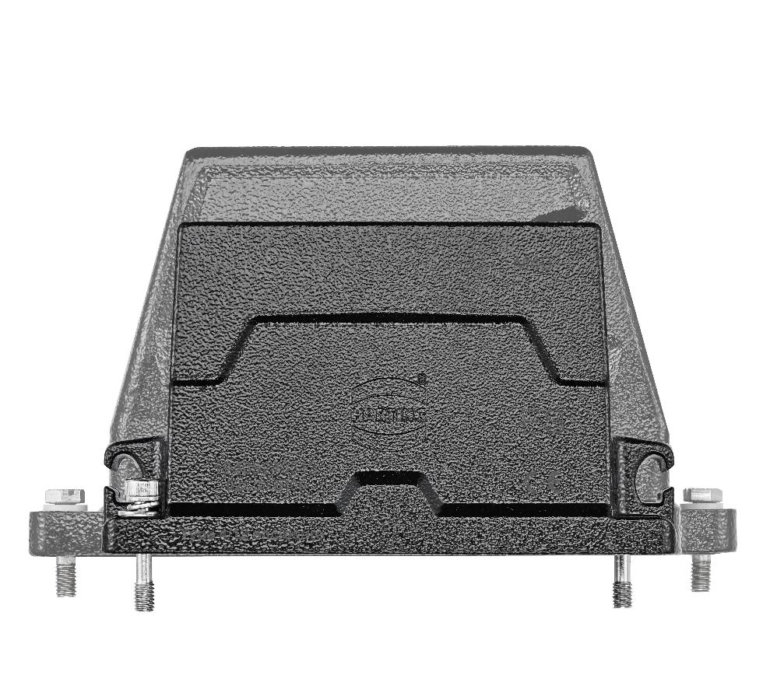
Caption: With the Han® HPR Compact (front) for interfaces, users save 20 percent of the installation space compared to previous solutions.

You also find the press release here:
www.HARTING.com/DE/en-gb/news/press-release

About HARTING:
The HARTING Technology Group is one of the world's leading providers of industrial connection technology for the three lifelines of Data, Signal and Power and has 14 production plants and 44 sales companies. Moreover, the company also produces retail checkout systems, electromagnetic actuators for automotive and industrial series use, charging equipment for electric vehicles, as well as hardware and software for customers and applications in automation technology, mechanical and plant engineering, robotics and transportation engineering. In the 2020/21 business year, some 6,000 employees generated sales of EUR 869 million.

Contact:
HARTING Stiftung & Co. KG
Detlef Sieverdingbeck
General Manager
Corporate Communication & Branding (CCB)
Marienwerderstr. 3
32339 Espelkamp - Germany
Tel.: +49 5772 47-244
Fax: +49 5772 47-400
Detlef.Sieverdingbeck@HARTING.com
More information at: www.HARTING.com

