Han® HPR HPTC:
High-performance interface for transformers, converters and power distribution equipment

Espelkamp / Hanover, 30 May 2022 - The connections of transformers are permanently exposed to intense environmental impacts: mechanical effects, water, oil, direct sunlight, and ozone can significantly reduce the service life of components. That is why the new Han® HPR HPTC series was developed especially for transformer applications in harsh environments.

The new system meets the requirements for a simple assembly including only a few components, thus ensuring maximum safety. On the cable side, a crimped contact is inserted into a three-part, touch-proof insulation body. In addition, there is a cable gland that protects against dust and moisture and forms part of the shielding, absorbing residual currents and transferring them to the enclosure.

HPTC hoods and housings use entirely metal contacts i. e. the cover and bottom part are connected to each other over the entire contact area. This is a new development, being the first transformer connector specifically designed for shielded transmission. However, the shielding can be achieved without shrinking and taping. In addition, an efficient coding system reduces storage requirements for the connector component.

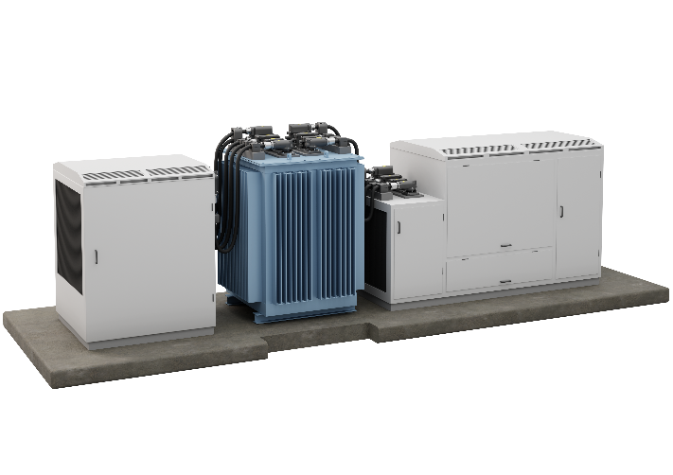

Caption: Han® HPR HPTC for connecting transformers, frequency converters (picture), power distribution equipment or battery storage systems / fuel cells. The series was developed for transmitting high currents. It is easy to install and protects from even massive external impacts.
You also find the press release here:
www.HARTING.com/DE/en-gb/news/press-release

About HARTING:
The HARTING Technology Group is one of the world's leading providers of industrial connection technology for the three lifelines of Data, Signal and Power and has 14 production plants and 44 sales companies. Moreover, the company also produces retail checkout systems, electromagnetic actuators for automotive and industrial series use, charging equipment for electric vehicles, as well as hardware and software for customers and applications in automation technology, mechanical and plant engineering, robotics and transportation engineering. In the 2020/21 business year, some 6,000 employees generated sales of EUR 869 million.

Contact:
HARTING Stiftung & Co. KG
Detlef Sieverdingbeck
General Manager
Corporate Communication & Branding (CCB)
Marienwerderstr. 3
32339 Espelkamp - Germany
Tel.: +49 5772 47-244
Fax: +49 5772 47-400
Detlef.Sieverdingbeck@HARTING.com
More information at: www.HARTING.com

