Han-Eco®
Low contact resistance helps save energy

Espelkamp / Hanover, 30 May 2022 - Plug & Play connectors from HARTING reduce the energy consumption of IT equipment. The Han-Eco® connector, for example, minimises voltage losses at data centre units by up to 50 %, which is made possible by using particularly low-impedance contacts.

HARTING has analysed the effects of this connector on the operating costs of data centres and compared them with those of connection technology solutions from other manufacturers. It was shown that the power consumption for operating the IT infrastructure is halved when using the most economical connector in each application. The Han-Eco® proves to be a particularly sustainable infrastructure component for data centres that offers both customers and users a concrete added value, thus making it a Connectivity+ product.

CEE plugs according to IEC 60309 are widely used in this industrial sector as standard components for connecting computer components. HARTING compared two of these so-called conventional solutions – including that of the market leader – with the Han-Eco® connector, each in the 63 A variant. A savings potential was detected, which essentially results from the differences in voltage losses. The Han-Eco® has advantages here, as its contacts only had about half the voltage drop of the CEE solutions in the test environment. The result is savings of up to 95,000 € or 760,000 kWh per year (for a data centre with 15,000 racks).

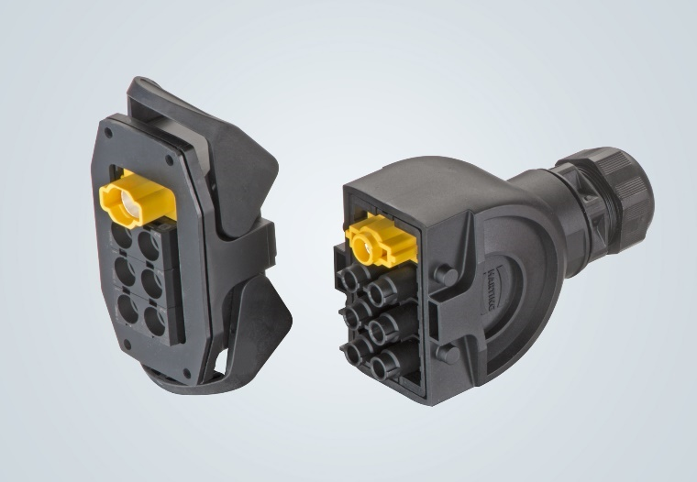

Caption: Han-Eco® for data centres: In tests, the voltage drop at the contacts was only half that of comparable CEE solutions.

You also find the press release here:
www.HARTING.com/DE/en-gb/news/press-release
About HARTING:
The HARTING Technology Group is one of the world's leading providers of industrial connection technology for the three lifelines of Data, Signal and Power and has 14 production plants and 44 sales companies. Moreover, the company also produces retail checkout systems, electromagnetic actuators for automotive and industrial series use, charging equipment for electric vehicles, as well as hardware and software for customers and applications in automation technology, mechanical and plant engineering, robotics and transportation engineering. In the 2020/21 business year, some 6,000 employees generated sales of EUR 869 million.

Contact:
HARTING Stiftung & Co. KG
Detlef Sieverdingbeck
General Manager
Corporate Communication & Branding (CCB)
Marienwerderstr. 3
32339 Espelkamp - Germany
Tel.: +49 5772 47-244
Fax: +49 5772 47-400
Detlef.Sieverdingbeck@HARTING.com
More information at: www.HARTING.com

