**Han-Modular® Domino Modules**

The next level of modular industrial connectors

**Espelkamp / Hanover, 30 May 2022 - HARTING has accompanied and supported industrial transformation for more than 70 years. At present the challenges are different, but the foundation for today’s industrial transformation is formed by basic technologies such as interfaces for the transmission of power, data and signals. HARTING is therefore launching the Han-Modular® Domino Modules, which will take the world of modular industrial connectors to the next level. They open up new possibilities for optimisation, including space and weight savings of up to 50 %, thus reducing the CO2 footprint. The product also convinced the jury of this year’s HERMES Award. The Han-Modular® Domino Modules were selected as one of the Top 3 Innovations of 2022.**

Just as a domino has two separate squares, a Domino Module is composed of two “cubes”. The standard Han-Modular® mating face is split into two almost square surfaces, in which even larger contacts can be accommodated. The cubes support the configuration of customized connectors that are precisely tailored to the requirements of a design. Power, signal and data or compressed air as well as male and female contacts can be combined in one module. Overall, the number of required interfaces per unit is reduced. The connection technology becomes smaller and more lightweight as more modules and module types than before fit into one connector.

HARTING designates products that adapt to social megatrends such as sustainability and demographic change as “Connectivity+”. The Domino Modules are among them, because they help to reduce costs in the assembly and operation of machines and systems and save resources. This applies both to production – manufacturing smaller components uses less material and energy – and transport, which benefits from the space and weight savings as well as more flexibility. Individual assemblies can also be reused, improving sustainability.

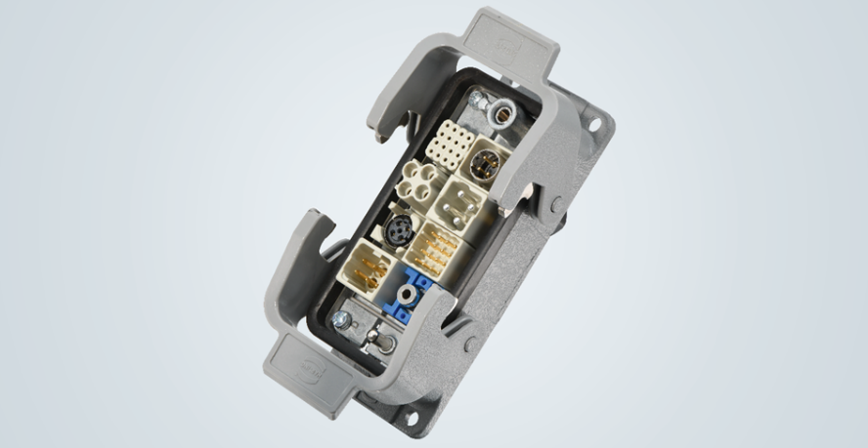

**Caption:** Modular Han® B housing; instead of 4 conventional modules, there is now space for 8 Domino cubes.

Ein Bild, das Kuchen, Elektronik, Buchse, Adapter enthält.

**Caption:** Customised Domino Modules: Signal contacts can be combined with M12 data transmission (up to10 Gbit/s) to save space.

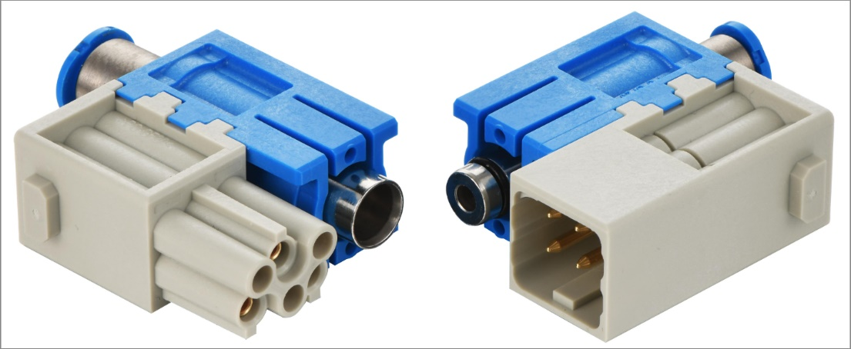

**Caption:** Different transmission media types such as compressed air (blue module) and power/signals can be combined in one module, forming hybrid interfaces.

You also find the press release here:  
[www.HARTING.com/DE/en-gb/news/press-release](https://www.har.com/DE/en-gb/news/press-release)

**About HARTING:**

The HARTING Technology Group is one of the world's leading providers of industrial connection technology for the three lifelines of Data, Signal and Power and has 14 production plants and 44 sales companies. Moreover, the company also produces retail checkout systems, electromagnetic actuators for automotive and industrial series use, charging equipment for electric vehicles, as well as hardware and software for customers and applications in automation technology, mechanical and plant engineering, robotics and transportation engineering. In the 2020/21 business year, some 6,000 employees generated sales of EUR 869 million.

**Contact:**

HARTING Stiftung & Co. KG

Detlef Sieverdingbeck

General Manager

Corporate Communication & Branding (CCB)

Marienwerderstr. 3

32339 Espelkamp - Germany

Tel.: +49 5772 47-244

Fax: +49 5772 47-400

Detlef.Sieverdingbeck@HARTING.com

More information at: www.HARTING.com