HARTING is making Connectivity+ tangible at the HANNOVER MESSE 2022
As the trade fair celebrates its anniversary, the Technology Group will be presenting innovations and products that bridge the gap between social and technological trends

Espelkamp/Hanover, 30 May 2022 --- Finally, after a two-year hiatus due to the pandemic, the HANNOVER MESSE has returned and opened its doors as an in-person event once again. The HARTING Technology Group is in attendance and hosting its traditional press conference in front of an audience of industry journalists, partners and trade fair visitors.

“The 2022 HANNOVER MESSE is a very special event for HARTING,” said Philip Harting, CEO of the Technology Group, as he opened the press conference. “It is the first edition of the trade show since the return of in-person events – allowing us to meet with visitors face-to-face again at last. At the same time, it is celebrating its 75th anniversary, for which we express our congratulations. At the HARTING Technology Group, we celebrate this milestone with you, as we have attended ever since the very outset of the event in 1947.”

The overarching motto of this year’s fair in Hanover is: “Let’s create the industry of tomorrow”. The Technology Group seized this as an opportunity to showcase some of its products and solutions on the topic of Connectivity+ at a trade fair for the very first time. For HARTING, Connectivity+ bridges the gap between social and technological megatrends, through to its own products and solutions. “We are shaping the connectivity of the future with solutions that provide innovative added value for our customers,” explained Dr Kurt D. Bettenhausen, Management Board Member for New Technologies and Development, as he outlined the concept. “Connectivity+ extends far beyond the electronic component itself. This means it is not about a single connector but about the approach as a whole.”
This year, the spotlight is on a world first: the Han-Modular® Domino Modules, which represent a crucial building block in meeting the requirements of the industrial transformation.
Following the press conference, the journalists present had the opportunity to take part in ‘PressSpeedDates’, in which experts were on hand to discuss the presented topics and tackled questions from industry reporters in one-on-one interviews.

An overview of the HARTING Technology Group’s highlights (Location: Hall 11, Stand C 15):

- Modularisation: The world première of the Han-Modular® Domino Modules. Visitors to the Hannover Messe can experience the next generation of industrial connectors as the enabling technology of today’s industrial transformation and digitalisation for the first time at a trade show. These modules meet the ever-growing demands from industry for weight savings and ever tighter installation space. Optimised space utilisation combined with maximum flexibility for hybrid systems achieves weight reductions of up to 50%. This reduces the associated carbon footprint throughout the value chain, from the connectors’ production to their transport and subsequent use by customers.
- All for Energy: By leveraging savings potential through the targeted use of connector solutions, HARTING tackles the topics of energy efficiency and decarbonisation through its Han® HPR HPTC and Han-Eco® products.
- All for Ethernet: This is the place to go for trade fair visitors interested in industrial Ethernet infrastructure. The Technology Group is shining a light on new interfaces, a new M12 PushPull standard and single-pair Ethernet.
- All for PCB: HARTING provides answers to key questions: What benefits can digital services provide for a specific connector set-up using printed circuit boards? What role do product data and configurators play in this context?
- 3D MID: Customised 3D MID solutions for automotive engineering, industry and medical technology. However, new approaches in a sub-assembly standard for flexible use in wide-ranging situations plays a role at the HARTING trade fair stand.
- Digital services: News and developments regarding configurators and digital services, such as product configurators and smart data models.
- e-Mobility: Casting the spotlight on modern, standardised AC/DC charging solutions – from charging sockets to components for flexible battery storage systems.
You can find further details of the connector solutions and digital services listed here in our press kit at: https://www.harting.com/DE/en-gb/news/press-release

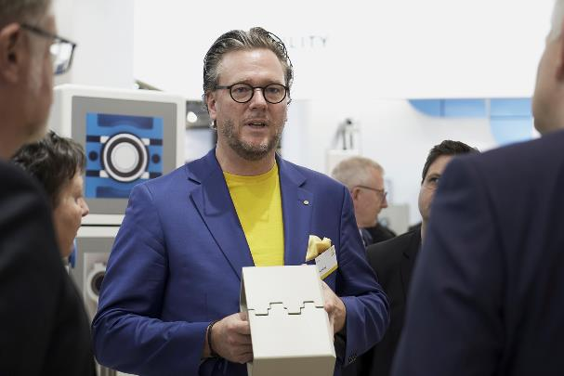
Caption: Philip Harting, CEO of the HARTING Technology Group, used a model to present the functionality of the Han-Modular® Domino modules to the attending trade fair audience.

About HARTING:
The HARTING Technology Group is one of the world's leading providers of industrial connection technology for the three lifelines of Data, Signal and Power and has 14 production plants and 44 sales companies. Moreover, the company also produces retail checkout systems, electromagnetic actuators for automotive and industrial series use, charging equipment for electric vehicles, as well as hardware and software for customers and applications in automation technology, mechanical and plant engineering, robotics and transportation engineering. In the 2020/21 business year, some 6,000 employees generated sales of EUR 869 million.

Contact:
HARTING Stiftung & Co. KG
Detlef Sieverdingbeck
General Manager
Corporate Communication & Branding (CCB)
Marienwerderstr. 3
32339 Espelkamp - Germany
Tel.: +49 5772 47-244
Fax: +49 5772 47-400
Detlef.Sieverdingbeck@HARTING.com
More information at: www.HARTING.com

