HARTING creating solutions for the megatrends of our times

Espelkamp/Hanover, 16 April 2023 --- Under the motto of "Making The Difference", HANNOVER MESSE has once again organised this year's Press Highlight Tour. Interested journalists were able to learn more about the most exciting innovations at this year’s Hannover Messe even before the event kicks off, including the latest products from the HARTING Technology Group. In addition to the revolutionary SmEC (Smart Electrical Connector), the company is presenting a charging solution for racing cars in the Formula E racing class.

Setting new standards in industrial digitalisation
Together with Microsoft, SAP (software and data evaluation) and Siemens (as a user), HARTING is presenting a "digital twin" as a real-world technology demonstrator. This is based on the first connector (Smart Electrical Connector) featuring an AAS (Asset Administration Shell), which represents the foundation of the digital twin. The connector records all the relevant process and condition data over the entire life cycle. The AAS as a digital twin for components, machines, plants and entire factories can be customized as desired thanks to partial models, ensuring consistent design and simplifying production planning. What’s more, the AAS saves millions of tonnes of paper by way of digital documentation. In addition, it enables a transparent CO2 footprint and corresponding savings measures. "In future, we will be seeing further potential, especially in terms of sustainability. The circular economy, for example, will benefit significantly from these developments" as Norbert Gemmeke, Managing Director of HARTING Electric stated.

Pushing performance with individual high-performance charging solutions

Together with ABB, HARTING will also be presenting a charging device for Formula E racing cars. The technology group is supplying the client with a customised charging cable for this purpose. The cable combines a standard CCS2 charging connector on the vehicle side with a HAN® HPR connector providing a high voltage modular solution on the infrastructure side, allowing the charging cable to be removed. HARTING is also showcasing its new high-performance DC charging connectors for the American and European markets, thereby significantly expanding the technology group's current DC product portfolio.

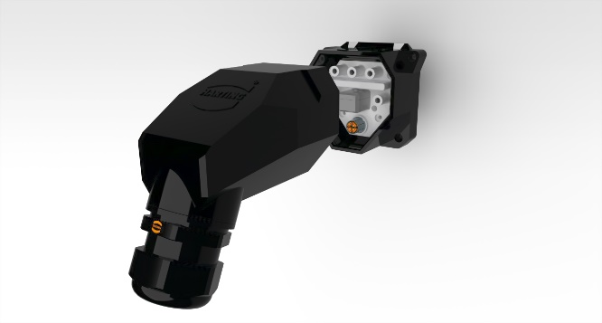

Caption: The HARTING SmEC is the first connector featuring an active asset administration shell.
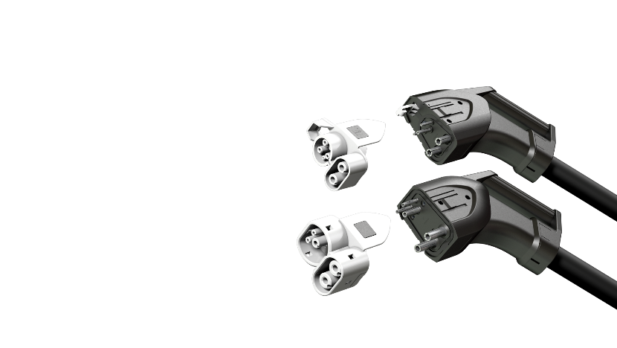
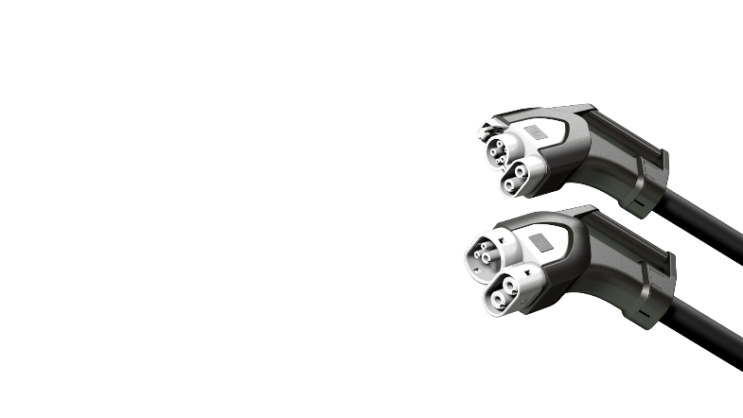

Caption: The new HARTING DC charging connectors impress with their outstanding performance.

About HARTING:
The HARTING Technology Group is one of the world's leading providers of industrial connection technology for the three lifelines of Data, Signal and Power and has 14 production plants and 44 sales companies. Moreover, the company also produces retail checkout systems, electromagnetic actuators for automotive and industrial series use, charging equipment for electric vehicles, as well as hardware and software for customers and applications in automation technology, mechanical and plant engineering, robotics and transportation engineering. In the 2021/22 business year, some 6,500 employees generated sales of EUR 1,059 million.

Contact:
HARTING Stiftung & Co. KG
Detlef Sieverdingbeck
General Manager
Corporate Communication & Branding (CCB)
Marienwerderstr. 3
32339 Espelkamp - Germany
Tel.: +49 5772 47-244
Fax: +49 5772 47-400
Detlef.Sieverdingbeck@HARTING.com
www.HARTING.com

Contact:
HARTING Stiftung & Co. KG
Tara-Luise Winkelmann
Professional Corporate Communication
Corporate Communication & Branding (CCB)
Marienwerderstr. 3
32339 Espelkamp – Germany
Tel.: +49 5772 47-9447
TaraLuise.Winkelmann@HARTING.com
http://www.HARTING.com

