Han-INOX® stainless steel housings protect against corrosion and aggressive substances

Espelkamp, 14 November 2023 --- The Han-INOX® connector series featuring stainless steel housings is now completely available in Han® B format. The corresponding bulkhead mounted housings and hoods, with top or side cable entry as well as with protection cover, are available in the sizes Han® 6 B to 24 B.
This positions HARTING as the only manufacturer providing a complete range of connectors in stainless steel housings, ranging from size Han® 3 A all the way up to Han ® 24 B. This enables the realisation of sensor applications or the connection of machines to the power supply – also in harsh corrosive or caustic ambient conditions.
The use of Han-INOX® is sustainable: thanks to the durability of the housing material, the connectors are reliable partners withstanding adverse and harsh operating conditions. The installation dimensions of the established Han® B and Han® 3 A sizes facilitates upgrading installations to the most robust industrial connectors. Given the full compatibility with the inserts of the Han® and Han-Modular® series, users maintain the necessary flexibility, e.g. for combinations with existing machine modules.
Han-INOX® is predestined for applications in the food and beverage industry, as in scenarios involving packaging machines, for example. In addition, stainless steel connectors are often in demand in the energy sector. Moreover, their strengths are advantageous in scenarios involving new hydrogen-based generation technologies. The series also offers elegant solutions in transferring larger machines from "typical" industrial environments to harsher, more demanding ambient conditions.

The advantages at a glance:
- Hoods, housings, locking levers and cable glands made of stainless steel
- Corrosion/weather resistant
- Resistant to aggressive chemicals/cleaning agents
- Long life cycles
- Compatible with existing standard connectors of the sizes Han® B and Han® 3 A

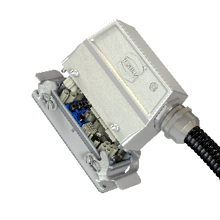

Captions: Stainless steel hood and housing Han-INOX® in standard size 24 B - equipped here with Han-Modular® frame and Domino modules for the transmission of power, data, signals and pneumatics.
About HARTING:
The HARTING Technology Group is a leading global provider of industrial connectivity. Around 6,500 employees are active across the globe in 44 sales companies, 15 production facilities and six development sites. HARTING connectivity solutions are used to transmit "data, signals and power" in numerous industrial sectors. Among others, in transportation, electromobility, renewable energy production, automation and mechanical engineering. In the 2021/22 business year the family owned and managed company generated sales of EUR 1,059 million.

Contact:
HARTING Stiftung & Co. KG
Detlef Sieverdingbeck
General Manager
Corporate Communication & Branding (CCB)

Marienwerderstr. 3
D-32339 Espelkamp

Tel.: +49 5772 47-244
Detlef.Sieverdingbeck@HARTING.com

