HARTING enabling Smart Production Solutions

Espelkamp, 14 November 2023 --- Digitalisation, de(globalisation), sustainability and energy efficiency: these crucial issues are currently preoccupying our society. In line with the trade fair motto of "Bringing Automation to Life", at SPS 2023 in Nuremberg, HARTING will once again be showcasing innovations and solutions geared to meeting these challenges.
The Technology Group refers to the underlying concept as Connectivity+. Pursuing this approach, HARTING examines the social and technological megatrends and harnesses them to develop solutions that extend far beyond conventional electronic components. This year’s main focus: connection technology addressing the megatrend of sustainability and the technology trend of the digital twin. In this way, the technology group is actively shaping the industrial transformation.
In the run-up to the traditional HARTING press conference, Philip Harting, CEO of the HARTING Technology Group, also took up the topic of challenges and commented on Germany’s economy: "The continuing high inflation rate, high energy costs, lack of investment in digitalisation and education and the worldwide geopolitical tensions are weighing on the development and planning security of companies. This is impacting on the German SME sector." With regard to the 2022/2023 business year (30 September 2023) elapsed, Edgar Peter Düning, commercial managing director of the Technology Group indicated a sideways movement in sales and revenue targets. The Technology Group will announce further details at its annual press conference on 1 December 2023.
"Sustainability is simply not possible without the digital twin"
HARTING is currently providing the digital twin for more than 18,800 products in the form of an asset administration shell. Dr Kurt D. Bettenhausen, Director of New Technologies and Development, is convinced: "Sustainability is simply not possible without the digital twin”. At the HANNOVER MESSE 2023, HARTING had already featured a digital twin technology demonstrator together with IDTA, Microsoft, SAP and Siemens. The focus was on digital twin life cycles. For the SPS 2023, the Technology Group will be showcasing further developments geared to achieving greater sustainability. By way of the "Digital Product Passport" and "Product Carbon Footprint" sub-models, HARTING is using the demonstrator to illustrate that the digital twin holds the leverage to make our industrial world more sustainable.
Excellence in Connectivity meets New Energy
The Technology Group has set up an exemplary battery production unit at this year's SPS. Based on this demonstrator, the company is highlighting solutions for the energetic transformation. After all, HARTING connectors are not only at work directly on battery modules, but also in their production. The Han-INOX® is one such concrete solution, which has proved its worth in the food industry for years. With the latest portfolio expansion, in future HARTING will be able to cover all sizes from 6B to 24B as well as 3A. In addition, the Technology Group is presenting the new IP67 docking frames made of metal for the first time at this year’s SPS, enabling "blind" mating under adverse ambient conditions - for example in mechanical engineering. Other solutions include the new IP67 switch and the next expansion stage of the Han® Push-In portfolio featuring the first monoblock insert.
Together with the Hanover University of Applied Sciences and Arts and the Helmut Schmidt University Hamburg, HARTING will be presenting a live demonstration on the development of energy management interfaces for IoT technologies at this year’s SPS 2023. This is intended to simplify the dissemination and use of relevant energy consumption information – thereby ensuring sustainable action in industrial production and the efficient and prudent use of energy.
In addition to plug & play products for power distribution, HARTING will be showcasing solutions for the generation, processing and distribution of hydrogen at SPS 2023. These solutions include flexible connections for the transport of mobile storage units and individual and tested connection solutions geared to specific environments.

Ready for Single Pair Ethernet (SPE)
SPE is operational and ready for use. The Technology Group will be demonstrating this together with partners from the SPE Industrial Partner Network at the SPS, including Perinet - a sister company of the HARTING Technology Group. This specialist for the integration of sensors and actuators into the IP world is developing and producing new, innovative electronics and electromechanics components and the associated software – based on advanced, leading-edge technologies. By way of a live application, HARTING and partners will illustrate the manufacturer-independent, interactive functionality of SPE devices and components.
Moreover, the Technology Group is presenting a new circular connector in Nuremberg: The M17 series is ideal for miniaturised drives.
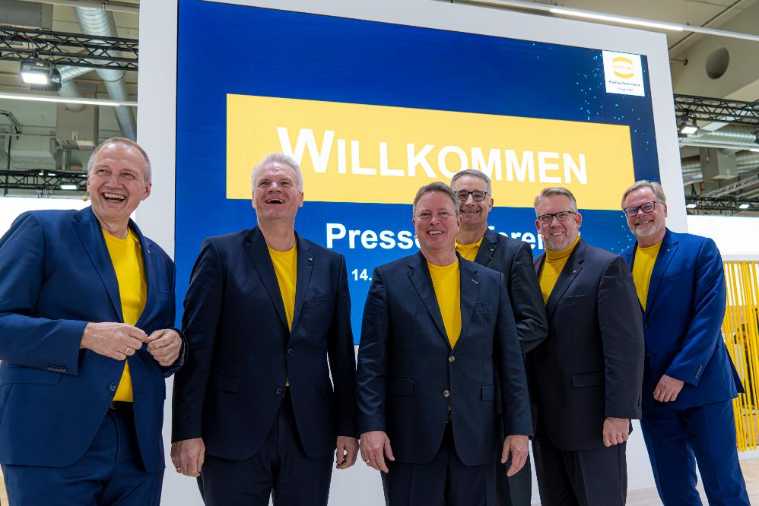
Caption: HARTING's management informed the journalists about the technology group's latest highlights and solutions.
About HARTING:
The HARTING Technology Group is a leading global provider of industrial connectivity. Around 6,500 employees are active across the globe in 44 sales companies, 15 production facilities and six development sites. HARTING connectivity solutions are used to transmit "data, signals and power" in numerous industrial sectors. Among others, in transportation, electromobility, renewable energy production, automation and mechanical engineering. In the 2021/22 business year the family owned and managed company generated sales of EUR 1,059 million.

Contact:
HARTING Stiftung & Co. KG
Detlef Sieverdingbeck
General Manager
Corporate Communication & Branding (CCB)

Marienwerderstr. 3
D-32339 Espelkamp

Tel.: +49 5772 47-244
Detlef.Sieverdingbeck@HARTING.com

