HARTING enabling smart energy management
M17 circular connector as new standard for compact drives +++ Operator interfaces for safe and secure operations +++ SPE Industrial Partner Network: Live SPE network application by HARTING and Perinet +++ IoT_EnRG: Live demonstration for the development of energy management interfaces for IoT technologies +++ M12 x-coded IDC
Espelkamp, 14 November 2023 --- When it comes down to climate protection and sustainable action, the best kilowatt hour is the one that is not consumed at all. Consequently, it is all the more important to make existing consumers more efficient and economical, to identify superfluous consumption and to make energy management data available in smart networks – and the HARTING Technology Group is addressing precisely these issues with suitable solutions.

M17 - The future standard size for miniaturised drives?

At present, circular connectors in size M23 serve the majority of all connections for drives and actuators in industrial applications. Due to the increased efficiency of the drives as well as digitalisation, miniaturisation and decentralisation, however, the number of compact drives is continuously trending upwards. New, more cost-efficient drive concepts also call for new, more compact interfaces. The dimensions and performance data predestine HARTING’s M17 series as the new standard for drives with up to 7.5kW power and beyond. With a rated voltage of up to 630V and a current carrying capacity of up to 26A at 40°C ambient temperature, the M17 series delivers very high power density for compact and efficient drives.
In order to reduce the number of interfaces on drives, the M17 connectors for hybrid solutions (power + signals + data) are also being standardised according to IEC 61076-2-117 as part of the "One-Cable-Automation" (OCA) initiative – meaning that future solutions will be plug-in compatible across manufacturers based on the respective standard.
Operator interfaces for safe and secure operations
At the SPS Nuremberg 2023, the Technology Group will be presenting the new product family of operator interfaces. The series of buttons, emergency stop switches and other operating elements combines the safe operation of devices with an attractive, modern design. As operator interfaces form the interface between man and machine, they must therefore meet the highest standards of safety, intuitive usability and reliability. The operating and command devices are available as: pilot lights, push buttons, key switches, selector switches and emergency stop switches. The operating elements sensibly complement the visually appealing interfaces for high-quality panel feed-throughs of the previous har-port series. These are available as interfaces for USB type A, B and C, RJ45, audio (3.5 mm jack plug), video (HDMI) in addition to various accessories such as protection covers for IP protection, labels or holders.
All models are designed for housing installation and are available into two sizes: The size for a housing cut-out with a diameter of 22.3 mm caters to applications in automation, machinery and robotics. The size for a housing cut-out with a diameter 30.5 mm finds use in typical transportation applications. In addition to industrial-grade housing interfaces, users will now also benefit from reliable and robust operating elements from a single source.
HARTING and Perinet showing SPE network in action
The need for powerful data networks is also increasing in factory automation. Single Pair Ethernet is one of the key building blocks on the way to the Digital Factory and the IIoT. The significantly reduced infrastructure by comparison with existing solutions enables the resource-saving connection of the field level to existing Ethernet networks. Advantages such as the simultaneous supply of up to 50W power at the device and real-time capability via TSN over OPC UA, position SPE as the key for IoT applications. Now that the SPE ecosystem with components and devices has grown significantly in recent years, the focus is being increasingly placed on the first applications. Together with the Berlin-based company Perinet - the HARTING sister company specialising in sensor and actuator integration into the IP world and developing and producing new, innovative electronic and electromechanical components and the associated software based on advanced, leading-edge technologies – as well as other partners of the SPE Industrial Partner Network, HARTING will be showcasing a live application at SPS 2023 that illustrates the manufacturer-independent, interactive functionality of all SPE devices and components. The application shows an example of a factory automation use case and underlines impressively: SPE is operational and ready for use.
Keeping a keen eye on consumption: live demonstration on the development of energy management interfaces for IoT technologies
HARTING is supporting the "Development of energy management interfaces for IoT technologies - IoT_EnRG" research project of the Hanover University of Applied Sciences and Arts and the Helmut Schmidt University Hamburg with smart infrastructure. The research project is dedicated to developing a universal energy information model for the streamlined transmission of energy management data on to higher-level systems. The simplified dissemination and use of information on energy consumption ensures sustainable action in industrial production and the efficient and sparing use of energy. The demonstrator at the trade fair stand shows actual, real examples to illustrate how the energy management data from different factory automation protocols is translated into uniform semantics and passed on by way of OPC UA / MQTT.
M12 X-coded circular connectors for Gbit Ethernet now also field-terminable
On the occasion of this year’s SPS, HARTING is launching the M12 circular connector in field-terminable design with X-coding – an interface that can be conveniently and reliably connected in the field. In this way, Gbit Ethernet connections can also be assembled and connected in the field with the appropriate raw cable for demanding application environments: a simple and quick solution for the installation area.
With IP protection 65/67 to IEC 60529, a temperature range of -40°C to 85°C and a fully shielded housing, the connector is the ideal choice for Ethernet networks in industrial field applications. Depending on the application, there is a choice of locks with a conventional thread (IEC 61076-2-109) or the tool-free PushPull lock (IEC 61076-2-010). The latter is particularly suitable for time-critical (dis)assembly, or in applications that require frequent plugging and unplugging of connections.
SPE mating face T1 Industrial available in IP65/67 PushPull housing
The T1 Industrial Single Pair Ethernet (SPE) interface according to IEC 63171-6 is the mating face for SPE opted for by the international standardisation bodies ISO/IEC, TIA and IEEE for industry and its applications. The mating face is based on a modular system in which the data insert fits into the various housings of the HARTING product portfolio – meaning that all applications from IP20 to IP65/67 are possible. Newly featured for SPS 2023, HARTING is showcasing the T1 interface in the Mini PushPull housing.
The PushPull rectangular connectors lock with a clear audible feedback that provides users with unambiguous information on the secure connection – entirely tool free and no torques to worry about. A clearly audible "click" when plugged in and the interface is IP65/67 protected and vibration-proof locked - the integrated yellow "safety clip" prevents any unintentional actuation. For the remote power supply of sensors, actuators and devices, up to 50W can be transmitted by way of the SPE cable (PoDL - Power over Data Line).

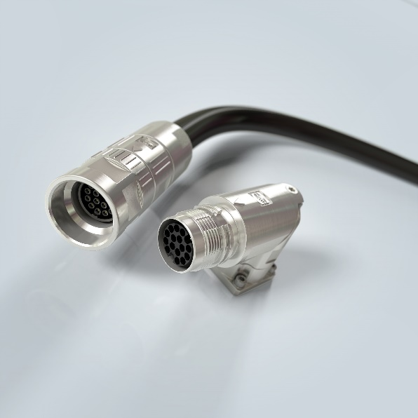
Captions: M17 circular connectors are the perfect choice for compact and powerful drives and servo motors up to 7.5kW

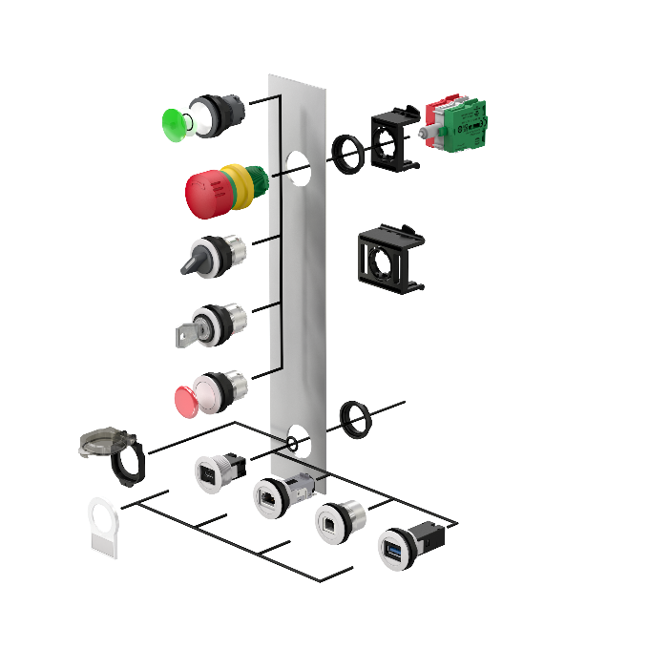
Captions: The series of operator interfaces will be expanded in 2023 with numerous human machine interfaces consisting of buttons, switches, emergency stop switches and many more. HARTING Operator Interfaces combine safe and secure operation and high-quality design.

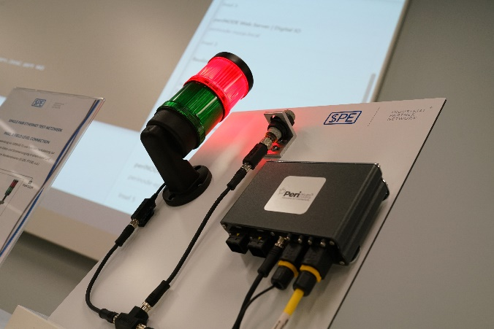
Captions: SPE is ready for factory automation - HARTING, Perinet and EKF will prove this in a joint live application at this year’s SPS.

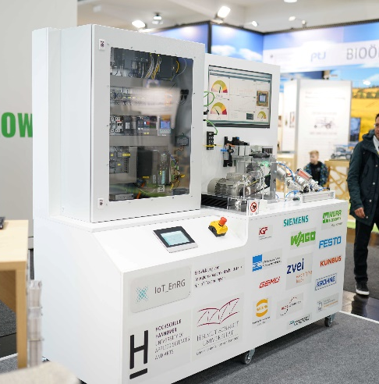
Captions: The IoT_EnRG research project aims to develop a universal energy information model enabling comprehensive energy monitoring in factory automation. HARTING is supporting the project undertaken by the Hanover University of Applied Sciences and Arts and the Helmut Schmidt University of Hamburg with the appropriate connectivity.

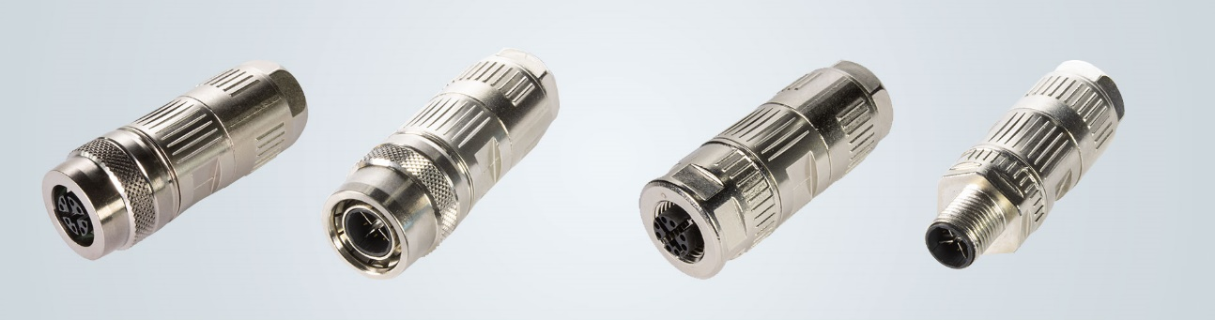
Captions: M12 circular connector X-coded now also available in field-terminable version. The ideal interface for high data rates in demanding installation scenarios.

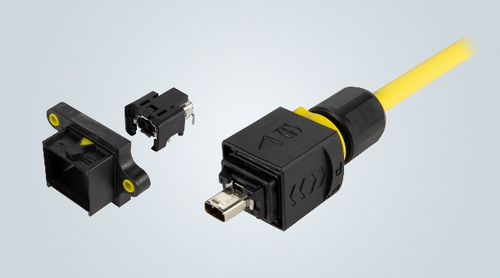
Captions: At the SPS 2023, HARTING will also be presenting the single pair Ethernet interface T1 Industrial (IEC 63171-6), now featuring an all-new IP65/67 protected Mini PushPull housing. Tool-free operation, audible feedback on secure locking and all round, totally safe protection of connections characterise the SPE connection for demanding and sophisticated tasks.

About HARTING:
The HARTING Technology Group is a leading global provider of industrial connectivity. Around 6,500 employees are active across the globe in 44 sales companies, 15 production facilities and six development sites. HARTING connectivity solutions are used to transmit "data, signals and power" in numerous industrial sectors. Among others, in transportation, electromobility, renewable energy production, automation and mechanical engineering. In the 2021/22 business year the family owned and managed company generated sales of EUR 1,059 million.

Contact:
HARTING Stiftung & Co. KG
Detlef Sieverdingbeck
General Manager
Corporate Communication & Branding (CCB)

Marienwerderstr. 3
D-32339 Espelkamp

Tel.: +49 5772 47-244
Detlef.Sieverdingbeck@HARTING.com

